Welcome to the latest edition of the weekly Somerset Covid-19 update for key stakeholders. This update is produced on behalf of the Somerset Covid-19 Engagement Board and is designed to provide a weekly update on the current Covid-19 situation in Somerset.
Thursday 1 July 2021
Somerset’s Covid-19 Weekly Update

Students have started returning home from University and there’s an important point to note if they have been told to self-isolate. Ideally, they should self-isolate for 10 days where they are currently living. However, if a student has to return home (for example, because a landlord insists they vacate their property) then they must complete the self-isolation period at home, and the rest of the household must also self-isolate with them. We are reminding people to be especially careful if you have someone who is clinically vulnerable in the household, and see if it’s possible to make other arrangements. What’s important is that wherever the student self-isolates, the rest of the household must self-isolate too.

Many of us around the county will be cheering England on this weekend as they play in the quarter-finals of the Euros. However, we are also urging everyone to watch the match responsibly, as we know that people are catching and spreading Covid-19 here in Somerset while gathering to watch the games. If you are going to the pub to watch, please remember to sign in, keep your distance and wear your mask when not seated. And if you have tested positive for Covid-19, have been told to self-isolate or have any symptoms, then, no matter how tempting it might be to go out to watch the game with your friends and family, please watch it at home – by doing so you are protecting yourself and others.

Latest Covid Dashboard: The following link below will take you to our website: Coronavirus (COVID-19) (somerset.gov.uk) Then scroll down the page until you get to ‘COVID-19 Dashboard’ in the list. Click on this and the dashboard will open. We apologise for the issues some of you have had recently with opening the link we have been sharing in this update.

‘Remember, everyone can catch it, anyone can spread it’.

Clare Paul, Cabinet Member for Education and Public Health
Twitter: @Clarepaul_

Professor Trudi Grant
Director of Public Health
Twitter: @SomersetDPH

David Fothergill
Leader of
Somerset County Council
Twitter: @DJAFothergill

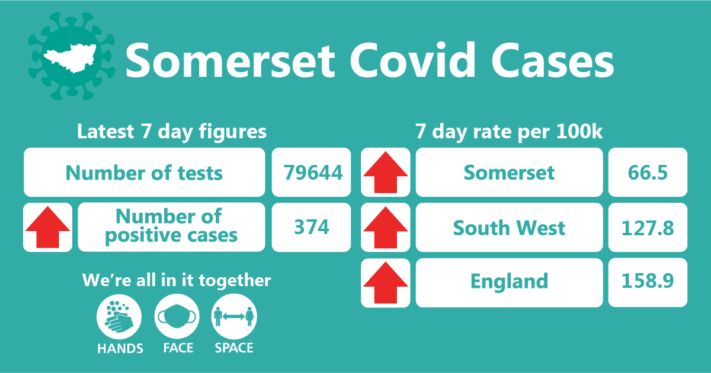
In the week up to 26 June approximately 79644 tests were carried out across the county and there have been 374 new confirmed cases. The rates have increased since last week and stand at 66.5 per 100,000, however we still remain well below the South West and England rates as you can see in this graphic.
The main items featured in this week’s update are:
- Workplace, care and school settings
- Vaccination update
- Testing Update
- Communications Focus
- Self-Isolation guidance
- Accessible resources
THIS WEEK’S HEADLINES:

Workplaces: We continue to promote regular testing as a vital tool in our fight against coronavirus. Businesses can give confidence to customers by ensuring that staff without symptoms test regularly to identify if they are carrying the virus. There are some very useful posters which can be downloaded from here which can show people your staff are testing regularly: Posters - Coronavirus Resource centre It is important for all business to be Covid-19 secure and there is some excellent guidance here: Working-safely-during-covid-19

Workplaces play a vital role in ensuring that any of their staff who test positive are reminded and supported to stay away from work for the full isolation period, to prevent the spread of the virus in the workplace, which could result in your business having to close if many staff are infected.

Care Sector: There have been 8 cases at 8 social care settings in the week ending 25 June 2021.

Mandatory vaccinations for care staff

Consultation outcome: Making vaccination a condition of deployment in older adult care homes

- The new legislation means from October (subject to Parliamentary approval and a subsequent 16-week grace period) anyone working in a CQC registered care home in England for residents requiring nursing or personal care must have 2 doses of a Covid 19 vaccine unless they have a medical exemption.
- It will apply to all workers employed directly by the care home or care home provider (on a full-time or part-time basis), those employed by an agency and deployed by the care home and volunteers deployed in the care home.
- Those coming into care homes for other work, for example healthcare workers, tradespeople, hairdressers and beauticians, and CQC inspectors will also have to follow the new regulations, unless they have a medical exemption.

New vaccine resources are available for adult social care:

- Your questions answered on the Covid 19 vaccine video – with professor Jonathan Van Tam and Dr Nikita Kanani
- Vaccine communications toolkit - new suite of resources to help care managers reassure staff about having the vaccine

Free webinar: More than moving (part of the Live Longer Better series)
Somerset Activity and Sports Partnership
8 July 2021 10.00 - 11.30 Register now
A short webinar in partnership with Age UK will explore the way in which physical activity can look at decreasing social isolation and loneliness while also giving an excellent boost to physical health. There will be a mix of speakers from across the country to include data and insight, practical solutions using physical activity and exercise to help combat loneliness and provide new social outlets plus there will also be the opportunity for you to contribute to future interventions with your insight and ideas from your experiences and settings.

The webinar is designed to be suitable for those working in adult health and social care settings including housing, charities as well as carers and micro providers.

Further information

Information and guidance related to Covid-19 within Adult Social Care settings is updated regularly, including guidance on PPE, testing, vaccinations, visiting and working safely within care homes, home care and day care – please visit Somerset Safeguarding Adults Board

Schools and Early Years settings: There are currently 46 situations in educational settings ranging from Early Years to Further Education settings. This includes single cases, clusters and outbreaks. Of these around 10 schools have decided to close bubbles.
There are several ways we can try and minimise covid19 cases in education settings, to avoid disruption to children’s education:

• We would advise that all educational staff, pupils aged over 11 years and the parents/carers of school aged children continue to take part in twice weekly asymptomatic testing.
• If anyone in the household is experiencing any of the symptoms of Covid-19, please isolate, seek a PCR test and the case and household to isolate until they have the results.
• If you are asked to self-isolate as a close contact of someone with Covid-19, we are now asking you to get a PCR test – this is called case finding and will help us to identify cases of Covid-19. You need to complete the full 10 days of isolation, even if that PCR result is negative.

Vaccination Update:

For the latest information about the Somerset vaccination programme and walk in vaccination clinics in the county this weekend, follow this link: Homepage - Somerset CCG T

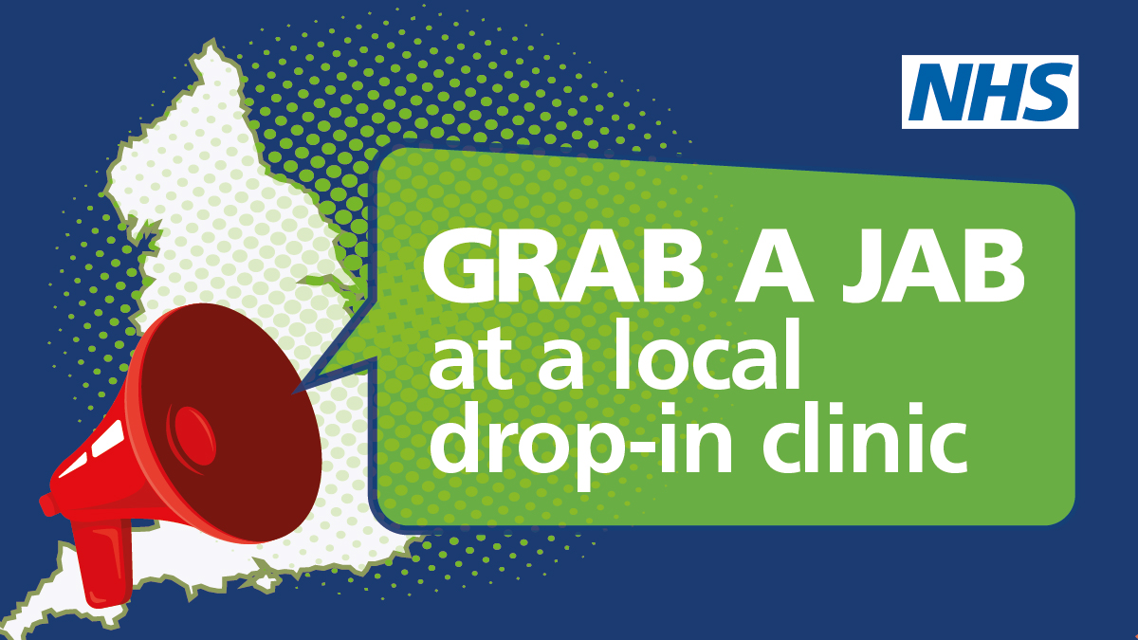

This week’s Covid Catch Up film presented by former BBC news correspondent Clinton Rogers is about the vaccination programme, and the importance of having the second dose. You can watch it here: Somerset Covid Catch up - Week 30, 30 June 2021 - YouTube

Do you have, or know someone who has concerns over receiving the Covid-19 Vaccine?

Have you met someone who has questions and concerns about the Covid-19 vaccine that you haven’t had the time or knowledge to answer? We are working in partnership with Spark Somerset to try to help.

First, we are offering Vaccination Myth Buster Training for anyone who is in a position to talk to the public about the Covid-19 vaccination. We aim to keep this training jargon free and user friendly, and everyone is welcome! The next course is on Tuesday July 6 from 7-9pm and will take place via Zoom.

The training is delivered by Fatou Mendy Sambou from Public Health Somerset and Helen Fielden from Spark Somerset and covers the following:

- The latest information about how the vaccines work, how they’re made and possible side effects.
- Common myths and misconceptions about the vaccine.
- The basics of how to have open, supportive conversations.
- Where to signpost people to if they have more questions.

To find out more, and to book your place click HERE.

We also have a team of trained Vaccination buddies who are here to help! The programme enables people to be offered support via a ‘buddy’ who can help them to make informed decisions about having the Covid-19 vaccination.

People can be referred (or self-refer) to the scheme and a Vaccination Buddy will contact them by phone to discuss their concerns and offer information and reassurance.
Vaccination Buddies come from all walks of life and have the necessary skills and knowledge to support people in a friendly, non-judgemental way.

Communications Focus:

As we mentioned in the introduction, many of us around the county will be cheering England on this weekend as they play in the quarter-finals of the Euros. We know that Covid-19 is spreading when people gather together to watch the football, so please help us by sharing the following message which you will see on our social media from today:

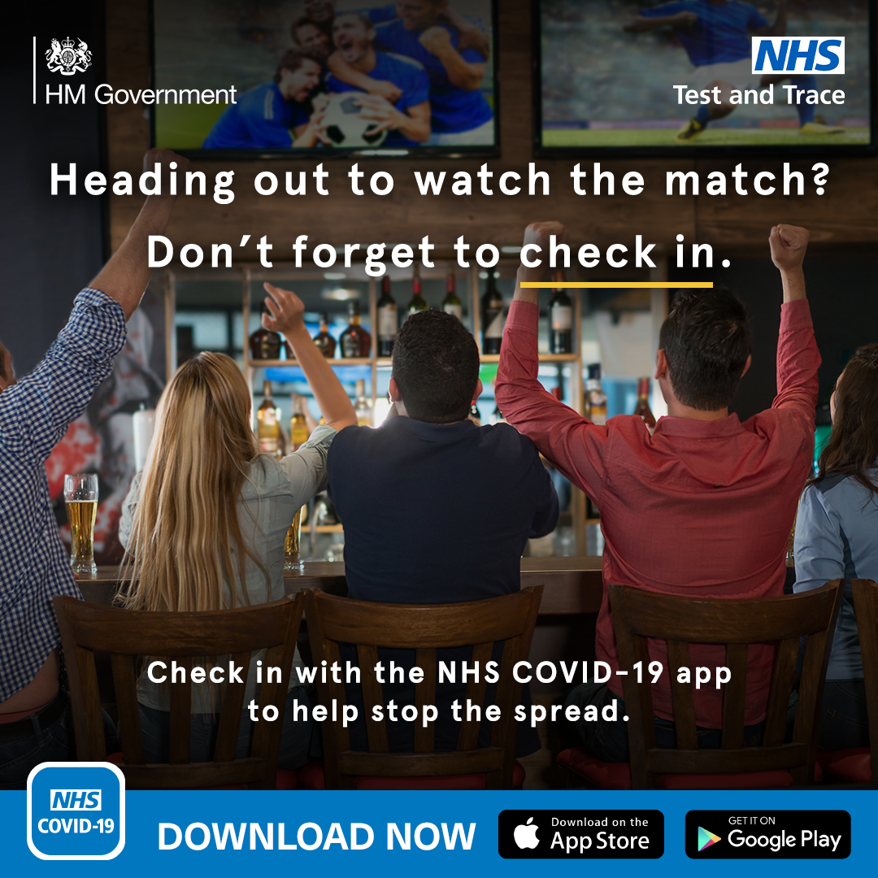

We are as excited as you about the big match on Saturday – C’mon England!
But please watch it responsibly as people are catching and spreading Covid-19 here in Somerset while gathering to watch the games. If you are going to the pub to watch - please remember to sign in and keep your distance – following the distancing guidance is crucial to breaking the chains of transmission. And if you have tested positive for Covid-19, have been told to self-isolate or have any symptoms, then, no matter how tempting it might be to go out to watch the game with your friends and family, please watch it at home – by doing so you are protecting yourself and others.

Resources and further information: Please do keep an eye our Healthy Somerset
website, which has a huge amount of information and resources to help keep everyone
healthy happy and safe at this time: https://www.healthysomerset.co.uk/covid-19/

For the latest local information as well as digital resources, posters and flyers please visit:
https://www.somerset.gov.uk/coronavirus/

The Somerset Local Outbreak Management Plan outlines how we, the council, will work
with the NHS Test and Trace Service, PHE, the NHS and other partners to ensure a whole
system approach to preventing and managing local outbreaks. This can be found here.

Finally, please like us on Facebook, follow us on Twitter and share our posts with your
networks to help us in communicating these important messages. Follow our Director of
Public Health account too here.

