Welcome to the latest edition of the weekly Somerset Covid-19 update for key stakeholders. The update is provided on behalf of the Somerset Covid-19 Engagement Board and is designed to provide a weekly update on the current Covid-19 situation in Somerset.
Thursday 18 March 2021
Somerset’s Covid-19 Weekly Update

Data is showing the case rates in Somerset decreasing but plateauing which is also reflected nationally and across the South West. Somerset’s rates are still comparably higher than our counterparts further South but less than some of our neighbouring areas further North. The number of patients in hospital with Covid-19 has decreased dramatically and our death rate for this time of year is far lower than we would usually see – aside from Covid-19.

National day of reflection is coming up on 23 March where we will reflect on our collective loss, support those who've been bereaved, and hope for a brighter future. It is really important also to remind ourselves how far we have come and how hard we have collectively worked to get us to this position – but lets not spoil it by doing too much too soon and allowing infection rates to creep back up again; whilst lockdown is set to be officially lifted on 29 March, there will still be guidance to follow within this easing of restrictions that will need to be adhered to.

Somerset’s seven-day infection rate has increased very slightly on last week’s rate of 38.8 and now stands at 39.3 new cases per 100,000.

The link below shows the Somerset Dashboard which tracks our local epidemic from the start in March, to the current time:

https://www.somerset.gov.uk/covid-19-dashboard/

‘Remember, everyone can catch it, anyone can spread it’.

Clare Paul, Cabinet Member for Public Health and Wellbeing
Twitter: @Clarepaul_

Trudi Grant
Director of Public Health
Twitter: @SomersetDPH

David Fothergill
Leader of
Somerset County Council
Twitter: @DJAFothergill

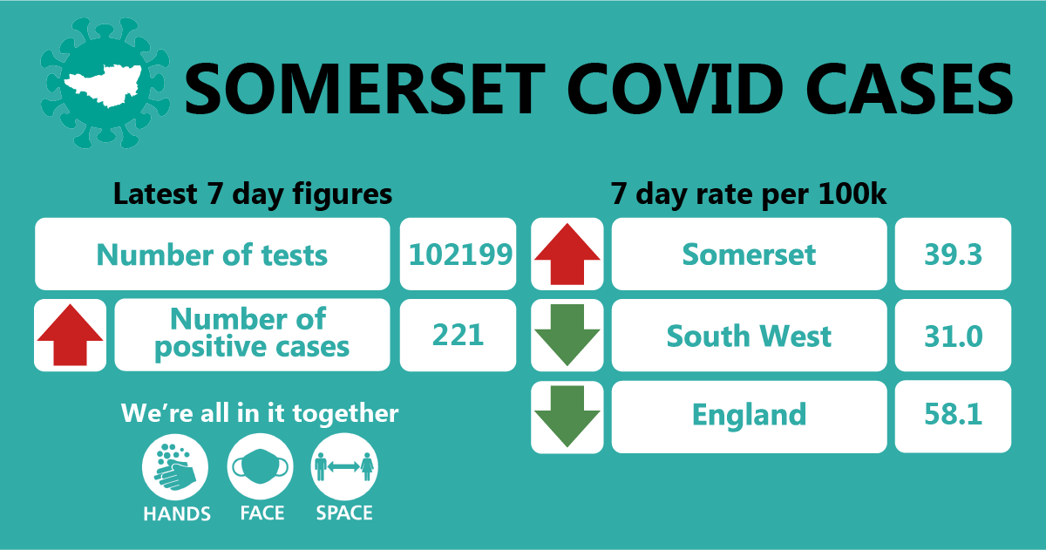
In the latest week, approximately 102199 tests were carried out across the county and there have been 221 new confirmed cases. The rise in tests and number of cases found is largely due to the increased lateral flow testing programmes and therefore identifying more asymptomatic cases.
THIS WEEK’S HEADLINES:
The main items this week that are featured in this update are:
- Enhanced Community Testing offer
- Workplace testing
- Schools and Care settings
- Covid Community Champions and vaccine buddies
- Advisory Network survey findings
- Communications and engagement focus
- Accessible resources

Workplaces: All businesses in England can register to order tests if the business is registered in England and its employees cannot work from home. Businesses must register on or before 31 March 2021 to get the forms they will need to order free lateral flow tests to test employees in the workplace here. Guidance for employers running testing programmes can be found here.

We are still seeing sporadic outbreaks occurring as people socialise in and around the workplace (where people cannot work from home). We continue to support these settings by providing public health advice and guidance around stopping the spread and reducing transmission. As employees start to return to the workplace in the coming months, it will be crucial that essential guidance such as Hands Face Space – in informal and formal work settings are adhered to, to keep everyone as safe as possible.

Care Sector: In the seven days to 18th March there were 13 cases across 8 care settings

The positive cases identified were staff and residents; we continue to support these settings with support and guidance on prevention measures.

For all the latest information and guidance related to Covid19 visit Coronavirus updates for Somerset Adult Care Providers – Somerset Safeguarding Adults Board (safeguardingsomerset.org.uk).

Schools and Early Years settings: We are thrilled to see the vast majority of our children and young people back in face to face education and thriving over the last two weeks.

In the week up to the 18th March there were 28 cases across 17 school settings.

Education staff now have access to regular asymptomatic testing which they can do at home. Students attending secondary schools, FE Colleges and special schools will also have access to this testing on their return to school and then on an ongoing basis at home. This testing is well underway across Somerset and has detected a small number of asymptomatic cases.

Guidance on how to use a home lateral flow test kit is available in other languages on this link to the Government website: COVID-19 PCR home test kit instructions - GOV.UK (www.gov.uk)

Community Testing using lateral flow devices – expansion of eligible groups:
Even though case numbers nationally and locally are reducing, we are still seeing cases within our society and regular testing helps to break the chain of transmission.

In Somerset, targeted community testing has already been in place for workers who care for vulnerable groups such as the elderly in their own homes. This testing sits alongside the multitude of national testing programmes. Somerset County Council’s Public Health has now expanded the offer and free, rapid lateral flow Covid-19 tests are now being offered to:
- Anyone whose job or volunteering work requires them to leave the house and be in contact with others
- Anyone who cares for others, either paid or voluntary
To book your test, please click here: https://somerset.maps.test-and-trace.nhs.uk/

If you are a parent, or part of household, childcare bubble or support bubble of school staff or a pupil – you can collect testing kits for you to do on yourself. Free ‘lateral flow’ test kits are available to collect from test sites across Somerset between set times. To find your nearest Somerset test collection site, please click https://somerset.maps.test-and-trace.nhs.uk/ and enter your postcode.
Lateral flow testing involves a swab of the nose and throat to collect a sample and provides a result within around half an hour. This screening test requires twice weekly testing.

- If you test negative
If your Lateral Flow Test result is negative, you have no symptoms and are not a close contact of someone who has coronavirus, you do not need to self-isolate but must continue the useful guidelines around Hands Face Space
- If you test positive
If your Lateral Flow Test result is positive, you will need to self-isolate with the rest of your household

For more information about Coronavirus testing, please Coronavirus – Getting tested (somerset.gov.uk)

Guidance on how to use a home lateral flow test kit is available in other languages on this link to the Government website: COVID-19 PCR home test kit instructions - GOV.UK (www.gov.uk)

Covid Community Champions: Our Covid Community Champions programme is growing, with more people from all walks of life volunteering to take part and share information with their communities to address local issues around Covid-19 and help to keep people as safe as possible.

Within the next month, the programme will run a training session for champions to give them the information they need to become ‘vaccination buddies’ (such as telephone befrienders, vaccination site volunteers, etc). With confidence around the vaccine wavering within particular groups, vaccine buddies will be a key part of ensuring that people get the right information from official sources and are reassured and informed about the vaccination process and its importance.

If you, or someone you know might be interested in a becoming a Covid Community Champion, you can find more information and sign up here.

Advisory Network Survey findings: The Health and Wellbeing Advisory Network helps us to understand the Covid-19 related communication and engagement needs of our communities across Somerset, especially our more vulnerable groups. As part of this network, we recently launched a survey with members designed to help us to gain a better understanding on the local picture in different groups across Somerset. Including insight on the barriers and issues that certain communities, groups and contacts may be facing.

The full report will be uploaded to the Advisory Network page here shortly but some key findings have been listed below; this all helps to shape our communications and engagement strategy so thank you to all of you that took part.
‘Stay at home’ restrictions
Language barriers and understanding culture have made following the ‘stay at home’ guidelines harder for some. Translations are available for many key government guidance documents, but this may not be enough.
Some people who lack the capacity to understand the many changes to the rules or maybe forget that there is a pandemic have struggled to follow the guidance and stay home as much as possible. Support groups have had to close which has resulted in individuals struggling with a change of routine and potential carer ‘burnout’.
Financial difficulties have determined how people have behaved throughout this pandemic. For some, self-isolation meant no income. Furlough resulted in many struggling to pay bills. Some felt they had to continue to work despite having symptoms or being a contact of a case in order to provide for their family.
Hands, face, space’ guidance

25% of respondents felt the community or group they represent were finding the ‘hands, face, space' guidance hard to follow. Most reported this was because of their mental health and not being able to see friends and family; isolation was particularly difficult.

A lack of understanding the guidance was again mentioned as a reason people found the ‘hands, face, space’ guidance hard to follow. For children, it has been confusing being allowed to be close to others whilst in school but having to physical distance when not at school.

Many public conveniences have been closed during the pandemic, reducing access to means necessary to follow the guidance.
Most people already follow the recommended guidance. 64% of those who responded to the survey thought that feeling more connected with others might encourage people to follow COVID-19 guidelines. Having a better understanding, knowledge or feeling more empowered were suggested to help. The messaging from the Government was said to have been confusing and open to interpretation. Clear messages and an example to follow are needed.
What might encourage people to follow COVID-19 guidance

Headline response: Feeling of being connected, empowered and supported came out high showing how important it is that we continue supporting people with advice on coping with anxiety, encouraging people to keep the bigger picture in mind, empowering people to make the right choices and actions to help us get back to normality.
Communications: Communications for this next week will focus on reinforcing guidance and helping people to stay safe whilst enjoying new freedoms. The message will be ‘let’s keep going’. We have all pulled together through these difficult times and we must remember to stick to the hands face space guidance and take a gradual approach to enjoying new freedoms one step at a time. Through our communications, we will encourage people to keep the bigger picture in mind, empowering people to make the right choices and do the right thing to help us get back to normality; by not going too fast but by enjoying new freedoms while keeping safe.

Resources and further information: Please do keep an eye our Healthy Somerset
website, which has a huge amount of information and resources to help keep everyone
healthy happy and safe at this time: https://www.healthysomerset.co.uk/covid-19/

For the latest local information as well as digital resources, posters and flyers please visit:
https://www.somerset.gov.uk/coronavirus/

The Somerset Local Outbreak Management Plan outlines how we, the council, will work
with the NHS Test and Trace Service, PHE, the NHS and other partners to ensure a whole
system approach to preventing and managing local outbreaks. This can be found here.

Finally, please like us on Facebook, follow us on Twitter and share our posts with your
networks to help us in communicating these important messages. Follow our Director of
Public Health account too here.

