This update is provided by the Somerset Covid-19 Engagement Board and is designed to provide a weekly update on the current Covid-19 situation in Somerset.
Thursday 11 March 2021
Somerset’s Covid-19 Weekly Update

This Monday saw us welcome our children and young people back in face to face education. The best thing we can do to keep our schools and other educational settings open and as safe as they can be is to try and keep the infection rates as low as they can be in our communities. This will help us to stop the infection getting into educational settings in the first place. Education staff now have access to regular asymptomatic testing which they can do at home. Students attending secondary schools, FE Colleges and special schools are also being tested.

In the latest Somerset Covid Catch Up film, Clinton Rogers returns to Court Fields School in Wellington, his old secondary school to see how the staff and students feel about the return to face to face lessons and the testing programme. You can watch it here: youtube.com/watch?v=Lg6wDQgxlDQ

While we are all pleased to have begun the slow journey out of the national lockdown, we really must continue to stress the need to exercise caution, and continue to practice ‘hands, face, space’. This applies even if you have received your covid-19 vaccination. As we as learn more from the vaccines, there is increasing evidence that having it does reduce transmission of the virus, but until we know for sure and enough people have been vaccinated we must ALL still continue to follow the rules. A national survey conducted in February found that 41 per cent of over 80s who had received the first dose of a vaccine within the last three weeks had met with someone other than a household member, care worker or member of their support bubble, indoors, since vaccination. So please help us to remind residents that it can take some weeks before protection from the jab kicks in and even then, it is vital to stick to the rules to protect ourselves and others.

‘Remember, everyone can catch it, anyone can spread it’.

Clare Paul, Cabinet Member for Public Health and Wellbeing
Twitter: @Clarepaul_

Trudi Grant
Director of Public Health
Twitter: @SomersetDPH

David Fothergill
Leader of
Somerset County Council
Twitter: @DJAFothergill

Somerset’s seven-day infection rate has decreased from last week’s rate of 49.3 and now stands at 38.8 new cases per 100,000.
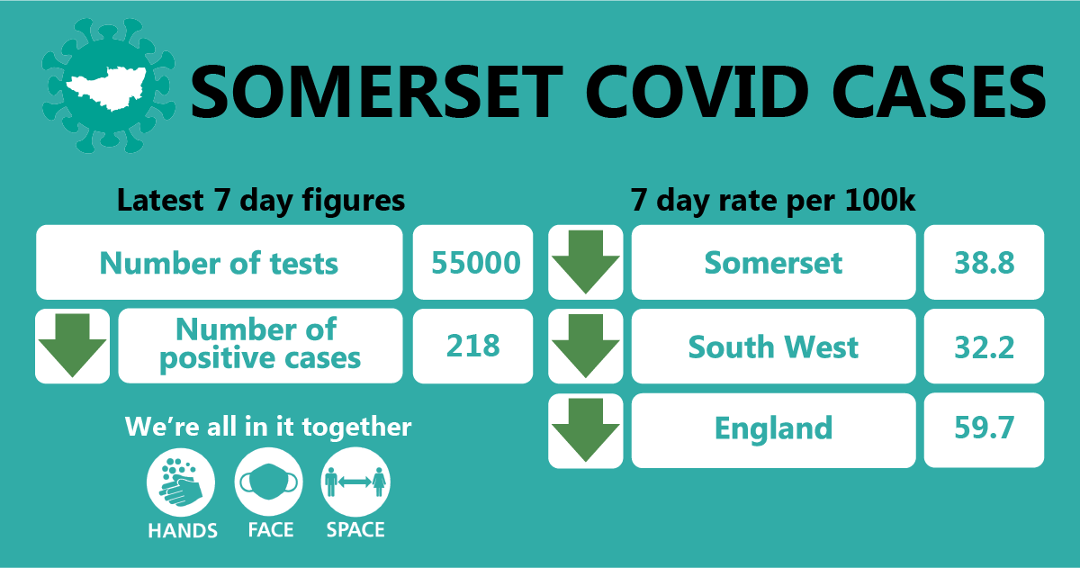

In the latest week, approximately 55,000 tests were carried out across the county and there have been 218 new confirmed cases.
The link below shows the Somerset Dashboard which tracks our local epidemic from the start in March, to the current time:

https://www.somerset.gov.uk/covid-19-dashboard/

Workplaces: All businesses in England are now able to sign up to the Government’s free Covid-19 workplace testing programme, including those with fewer than 50 employees (this was previously restricted to 50 or more employees).
Businesses can register to order tests if the business is registered in England and its employees cannot work from home. Businesses must register on or before 31 March 2021 to get the forms they will need to order free lateral flow tests to test employees in the workplace here. Guidance for employers running testing programmes can be found here.
We continue to see outbreaks occurring as people socialise in and around the workplace (where people cannot work from home) and unfortunately, are still seeing a number of outbreaks in the food sector. We are continuing to provide these settings with Public Health advice, support and guidance on prevention measures.

However, it is not just the food sector where transmission is occurring between colleagues. While we may be conscious of the need to socially distance, wear a mask etc when at work in formal settings, it is easy to relax and forget these measures in the company of colleagues in a staff room and inadvertently pass on the virus to them. We have produced a number of graphics showing this scenario that have been shared with businesses and will be re-shared on our social media channels in the coming weeks, to reinforce the importance of keeping up infection control measures even in informal settings such as lunch breaks.

Some common factors being seen across settings that are experiencing outbreaks include people car-sharing. Please help us to spread the message that currently, car sharing is not permitted with anyone from outside your household or support bubble unless your journey is undertaken for an exempt reason such as work. Where it is essential to car share, you can reduce the risk of transmission by:

- sharing the transport with the same people each time
- minimising the group size at any one time
- opening windows for ventilation
- travelling side by side or behind other people, rather than facing them, where seating arrangements allow
- facing away from each other
- considering seating arrangements to maximise distance between people in the vehicle
- cleaning your car between journeys using standard cleaning products – make sure you clean door handles and other areas that people may touch
- asking the driver and passengers to wear a face covering

For more information on car sharing visit: https://www.gov.uk/guidance/coronavirus-covid-19-safer-travel-guidance-for-passengers#car-sharing

Care Sector: In the seven days to 6th March there has been 19 cases across 11 care home settings. The positive cases identified were staff and residents; we continue to support these settings with support and guidance on prevention measures.

An important change for the care sector that took effect from Monday 8th March, is that care home residents will be allowed one regular visitor, provided that:
- there is not an outbreak in the setting,
- there are no other risks that the registered care home manager is aware of.
After being tested for Covid-19, provided they have a negative result and wear PPE, the visitor will then be allowed into the care home. This is welcome news for many people across the county.

For all the latest information and guidance related to Covid19 visit Coronavirus updates for Somerset Adult Care Providers – Somerset Safeguarding Adults Board (safeguardingsomerset.org.uk).

Schools and Early Years settings: We are thrilled to see the vast majority of our children and young people back in face to face education this week. Our children and young people have made huge sacrifices over the past year and it very important they are now given the opportunity to learn, play and thrive.

In the latest Somerset Covid Catch Up film, Clinton Rogers visits Court Fields in Wellington, to see how the staff and students feel about the return to face to face lessons and the testing programme. You can watch it here: youtube.com/watch?v=Lg6wDQgxlDQ

Education staff now have access to regular asymptomatic testing which they can do at home. Students attending secondary schools, FE Colleges and special schools will also have access to this testing on their return to school and then on an ongoing basis at home. This testing is well underway across Somerset and has detected a small number of asymptomatic cases.

It was announced this week that families, carers and support bubbles of school aged children will be able to access regular at home testing, and you can find out more about that here: Rapid lateral flow testing for households and bubbles of school pupils and staff - GOV.UK (www.gov.uk) Further information on the return to school can be found here.

Guidance on how to use a home lateral flow test kit is available in other languages on this link to the Government website: COVID-19 PCR home test kit instructions - GOV.UK (www.gov.uk)

Communications:

Road-map out of lockdown: Going forward, as we begin to ease restrictions and exit
the third national lockdown, our communications will be built on the local insight that
has been achieved through community engagement and through the Advisory Network.

This enhanced understanding of our local communities has helped to shape a phased
approach to communications that will sit alongside the Government’s ‘Road-map’.
Different groups will have very different feelings and concerns, but what we do know is
that our residents and communities want to feel motivated to remain positive and safe
and want to receive advice on coping with Mental Health and general wellbeing.
Through our communications, we will encourage people to keep the bigger picture in
mind, empowering people to make the right choices and do the right thing to help us get
back to normality; by not going too fast but by enjoying new freedoms while keeping
safe.

Getting tested for coronavirus:

In Somerset, lateral flow testing is already in place for workers who cannot work from
home, and who are in close contact with residents who are vulnerable. This offer was
extended to a further 43,000 workers on the 4th March 2021 but take-up remains low. For
now, appointments are by invitation only, so if you have not been contacted by us, this
means you are not currently eligible. However, as we roll out this programme further in
the coming weeks, we will update our website, so keep referring to the link above
for the most up to date information.

Many testing programmes are also being rolled out by the Government; to help you to
keep track of all these programmes, please see this page on the SCC website for more
information: Coronavirus – Getting tested (somerset.gov.uk)

Last week in Somerset just over 50,000 people were either tested when they had
symptoms or screened without symptoms, of those 0.5% were positive (roughly 250). It is
really important that people continue to get tested if they get symptoms www.gov.uk/get-coronavirus-test and participate in asymptomatic testing if they are
eligible.

Resources and further information: Please do keep an eye our Healthy Somerset
website, which has a huge amount of information and resources to help keep everyone
healthy happy and safe at this time: https://www.healthysomerset.co.uk/covid-19/

For the latest local information as well as digital resources, posters and flyers please visit:
https://www.somerset.gov.uk/coronavirus/

The Somerset Local Outbreak Management Plan outlines how we, the council, will work
with the NHS Test and Trace Service, PHE, the NHS and other partners to ensure a whole
system approach to preventing and managing local outbreaks. This can be found here.

Finally, please like us on Facebook, follow us on Twitter and share our posts with your
networks to help us in communicating these important messages. Follow our Director of
Public Health account too here.

