This update is provided by the Somerset Covid-19 Engagement Board and is designed to provide a weekly update on the current Covid-19 situation in Somerset.
Thursday 4 March 2021
Somerset’s Covid-19 Weekly Update

Last Monday, the Prime Minister set out the roadmap to easing the restrictions that we’ve all been living with for so long now. Full details can be found here: COVID-19 Response - Spring 2021 - GOV.UK (www.gov.uk)

While all of us will look forward to having a little more freedom, we really must continue to exercise caution. Next Monday is not the end of lockdown – far from it, and you will know that the Government has outlined four steps that must be met before restrictions are gradually lifted. Before proceeding to the next step, the Government will examine the data and there will be a minimum of five weeks between each step: four weeks for the data to reflect changes in restrictions, followed by seven days’ notice of the restrictions to be eased. The aim of this is to reduce the risk of having to re-impose restrictions at a later date. There’s more about this in the communications section on page 3.

On Monday, the first changes take place, and our children return to face to face education. Clinton Rogers’ latest Somerset Covid Catch Up film visits one of our Primary Schools to discuss this, and you can watch it here: Somerset Covid Catch-up Week 13, 3 March 2021 - YouTube
Another very important change from next Monday is that our care home residents will be allowed one regular visitor, provided they are tested and wear PPE.

Finally, we’d again like to encourage everyone to have the vaccination when it is offered to you. The focus of the vaccine programme at present is on reducing severe symptoms and death. As we as learn more from the vaccines, it will become clearer to what extent it will affect us passing the virus to others. For now, there is a chance that even if you are vaccinated, you could still inadvertently pass the virus onto someone who hasn’t received their vaccine yet, and they could become seriously ill.

‘Remember, everyone can catch it, anyone can spread it’.

Clare Paul, Cabinet Member for Public Health and Wellbeing
Twitter: @Clarepaul_

Trudi Grant
Director of Public Health
Twitter: @SomersetDPH

David Fothergill
Leader of
Somerset County Council
Twitter: @DJAFothergill
Somerset’s seven-day infection rate has decreased from last week’s rate of 75.4 and now stands at 49.3 new cases per 100,000.

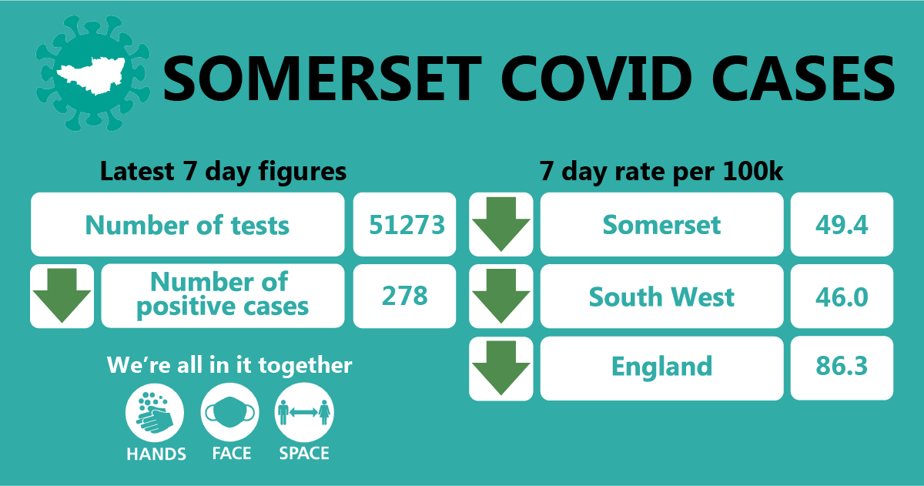

In the week leading up to 27 February, approximately 51,273 tests were carried out across the county and there have been 278 new confirmed cases.
The link below shows the Somerset Dashboard which tracks our local epidemic from the start in March, to the current time:

https://www.somerset.gov.uk/covid-19-dashboard/

Workplaces: As we said last week, you will have seen news coverage about outbreaks in factories, but we are also seeing outbreaks in office-based businesses such as accountants, solicitors and estate agents. It’s important to remember that working from home where you can is the best protection. If you do need to be in the office working with others, stick to the hands, face and space rules as much as possible, but be aware that by even following those rules, if there is someone in a poorly ventilated office who is asymptomatic or pre-symptomatic, they may very easily be able to pass the virus onto others. Spending several hours in an office with someone who is carrying the virus, even using face-coverings and two metre distancing, is a significant risk, as viral particles will build up in the air. That is why it is crucially important to ventilate the office, ideally continuously, but if not by regularly opening windows to freshen the air. So, make sure you dress warmly for work and ventilate, ventilate, ventilate!

Care Sector: In the seven days to 27 February there has been 36 cases across 24 care home settings. The positive cases identified were staff and residents; we continue to support these settings with support and guidance on prevention measures.

An important change taking place for the sector from next Monday, is that care home residents will be allowed one regular visitor, provided that the visitor is tested for covid-19, has a negative result and wears PPE.

For all the latest information and guidance related to Covid19 visit Coronavirus updates for Somerset Adult Care Providers – Somerset Safeguarding Adults Board (safeguardingsomerset.org.uk).

Schools and Early Years settings: Following the announcement made by the Prime Minister last week, all schools and colleges will be welcoming students back to face to face education from next Monday. We want to take this opportunity to reiterate our thanks to all our education staff who have worked so hard throughout this lockdown period to provide ongoing education for our children and young people. We also thank the children, young people, their families and carers who have adapted so well to these challenging times. We can’t wait to see everyone back at school, and as we mentioned in our introduction, Clinton Rogers’ Somerset Covid Catch Up film this week focuses on the return to school. He visits Willowdown Primary School in Bridgwater to discuss how they, and all our schools are preparing to welcome students back, and you can watch it here: Somerset Covid Catch-up Week 13, 3 March 2021 - YouTube

In order to help keep our schools and other educational settings as safe as we can, all education staff now have access to regular testing which they can do at home. Students attending secondary schools, FE Colleges and special schools will also have access to testing on their return to school and then on an ongoing basis at home. It was announced this week that families, carers and support bubbles of school aged children will be able to access regular at home testing, and you can find out more about that here: Rapid lateral flow testing for households and bubbles of school pupils and staff - GOV.UK (www.gov.uk) This is a really important step forward as we aim to keep community rates of the virus low and keep as many children and young people as possible in face to face learning. Further information on the return to school is here.

Communications:

- Route-map out of lockdown: As we highlighted in our introduction, we are not suddenly out of a full lockdown next Monday. The Government has published a four-step roadmap to ease restrictions across England and provide a route back to a more normal way of life. Each step will be assessed against four tests before restrictions ease, starting with the return of schools next Monday.
The four tests are:

- The vaccine deployment programme continues successfully
- Evidence shows vaccines are sufficiently effective in reducing hospitalisations and deaths in those vaccinated
- Infection rates do not risk a surge in hospitalisations which would put unsustainable pressure on the NHS
- Assessment of the risks is not fundamentally changed by new ‘Variants of Concern’

There will be a minimum of five weeks between each step: four weeks for the data to reflect changes in restrictions; followed by seven days’ notice of the restrictions to be eased. Government advises that the Chief Medical Officer and the Chief Scientific Adviser have made clear that this will give adequate time to assess the impact of each step and reduce the risk of having to re-impose restrictions at a later date.

Please help us remind our residents that easing of lockdown is a gradual process based upon the above tests. We have shared this information on our social media and will continue to do so, and you can help us by sharing our posts with your networks.

Getting tested: We have received feedback that it is hard to keep track of all the national and local testing programmes and so we have now brought these together into one page on our website. We hope this will serve as ‘one stop shop’ for advice on ‘Who, When, Why, How and Where’ people can get tested for covid19: Coronavirus – Getting tested (somerset.gov.uk)

In Somerset lateral flow testing is already in place for workers who cannot work from home, and who are in close contact with residents who are vulnerable. We have adopted a phased approach to this testing programme but it is expanding all the time. For now, appointments are by invitation only, so if you have not been contacted by us, this means you are not currently eligible. However, as we roll out this programme further in the coming weeks, we will update our website, so keep referring back to the link in the previous paragraph for the most up to date information.
We would like to take this opportunity to thank everyone who has been involved in helping us to set up and operate our lateral flow testing programme. This includes our own redeployed staff, District Council colleagues who have redeployed staff, RNAS Yeovilton, Devon and Somerset Fire Service, Somerset Waste Partnership, Bridgwater and Wiveliscombe Rugby Clubs and volunteers, friends and family. Thank you all for playing such an important role in our efforts to control the spread of coronavirus.

Covid-19 Vaccine: The latest national figures confirm that 20 million people across the country have now been offered the covid vaccination. Locally, the programme in Somerset has also reached a new milestone, with over 200,000 vaccinations given to people in the highest priority groups.

This is wonderful news, but we continue to work hard to reinforce the message that the vaccine is designed to prevent serious illness and death from Covid-19. Even if you have had the vaccine, you can still catch it and might still be able to pass it on, so the hands, face, space guidance must still be followed to protect yourselves and others.

Please help us by continuing to share the following with your networks:

If you haven’t had a vaccine yet,
If you have had one dose of the vaccine,
If you have had 2 doses of the vaccine,

The message is the same, we all need to STAY AT HOME where possible and keep following the HANDS FACE SPACE guidance to keep ourselves and others safe.

Resources and further information: Please do keep an eye our Healthy Somerset website, which has a huge amount of information and resources to help keep everyone healthy happy and safe at this time: https://www.healthysomerset.co.uk/covid-19/

For the latest local information as well as digital resources, posters and flyers please visit: https://www.somerset.gov.uk/coronavirus/

The Somerset Local Outbreak Management Plan outlines how we, the council, will work with the NHS Test and Trace Service, PHE, the NHS and other partners to ensure a whole system approach to preventing and managing local outbreaks. This can be found here.

Finally, please like us on Facebook, follow us on Twitter and share our posts with your networks to help us in communicating these important messages. Follow our Director of Public Health account too here.

