This update is provided by the Somerset Covid-19 Engagement Board and is designed to provide a weekly update on the current Covid-19 situation in Somerset.
Thursday 18 February 2021
Somerset’s Covid-19 Weekly Update

We continue to see a welcome decline in the rates of Covid-19 across the County. This is down to a combined effort of our fantastic NHS and health care services and people all across Somerset that have stayed home, made sacrifices and followed the hands face space guidance to keep the virus at bay.
The vaccination programme has entered a new phase with people aged 65 to 69 in England among those now being invited to book their Covid-19 jab.
As more people get vaccinated, it is beginning to feel like there is light at the end of a very long tunnel. When you are called for your vaccination, don’t hesitate, it really will protect you from becoming seriously ill from this virus. It is important to remember though that the vaccine doesn’t necessarily stop you contracting the virus; you may catch it but have milder symptoms.

The focus of the vaccine programme currently is on reducing severe symptoms and death; as more is known about the vaccines, it will become clearer to what extent it will affect us passing the virus to others. But for now, there is a chance that if you were to inadvertently pass the virus onto someone who hasn’t received their vaccine yet, they could become seriously ill.

So, yes by all means celebrate the vaccine and the positive impact it will have, but understand (and help others to understand too) that we must still all continue to keep following the guidelines to stay as safe as possible, in particular washing our hands regularly, wearing face covering when in public spaces and making space. Remember too that at the moment irrespective of the vaccine, we are still in a period of lockdown so should only be leaving home for essential reasons.

As we await the latest Government announcement around the ‘roadmap to recovery,’ lets all try to remain positive whilst in lockdown, appreciate the little things around us that make us smile, recognise our resilience and strength - we have come so far in our fight against this disease, we have all played some part and for that we should be proud.

‘Remember, everyone can catch it, anyone can spread it’.

Clare Paul, Cabinet Member for Public Health and Wellbeing
Twitter: @Clarepaul_

Trudi Grant
Director of Public Health
Twitter: @SomersetDPH

David Fothergill
Leader of
Somerset County Council
Twitter: @DJAFothergill

Along with the rest of the UK, locally we are seeing rates coming down.

Somerset’s seven-day infection rate has decreased considerably from last week’s rate of 135.4 and now stands at 81.1 new cases per 100,000 which as shown below is lower than the South West and England rates.
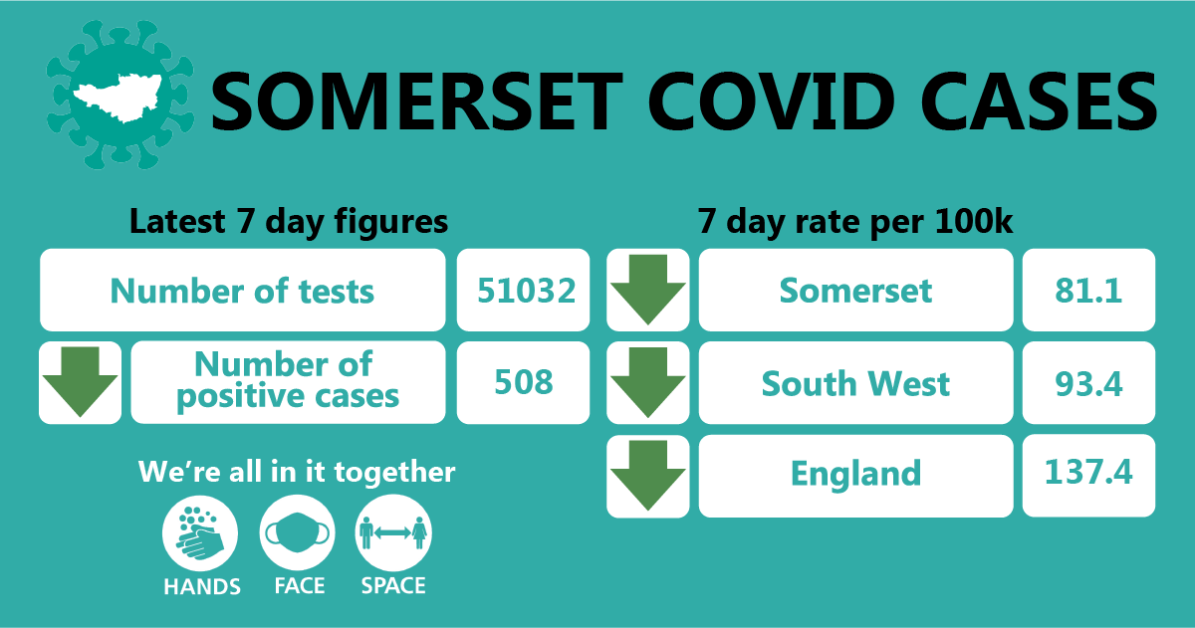

In the week leading up to 13 February, approximately 51,032 tests were carried out across the county and there have been 508 new confirmed cases.
The number of tests has increased due to the ramp up of testing (in particular, the rapid testing programme) but importantly, the number of positive cases has again reduced since last week’s update.
The link below shows the Somerset Dashboard which tracks our local epidemic from the start in March, to the current time:

https://www.somerset.gov.uk/covid-19-dashboard/

Workplaces: Larger employers in Somerset can now order coronavirus tests for their workforce if they cannot work from home. The direct route for ordering rapid Lateral Flow Tests has been set up for employers with 50 or more staff in England. Follow this link for more information: https://www.gov.uk/get-workplace-coronavirus-tests
Lateral flow tests are good at identifying people who don't have symptoms and who may have infection when they may not otherwise have been picked up. However, they do not pick up all infections.

This is why following a negative result, it is important that people continue to follow all national guidelines regarding social distancing, wearing face coverings and washing their hands regularly. The benefit of these tests is that they will identify some asymptomatic or pre-symptomatic positive cases, helping to break transmission chains. The downsides include the relatively high false negative rate, and the significant resources required to test the workforce repeatedly.
Working during lockdown: You can only leave home for work purposes where it is not possible to work from home.
This includes people who work within critical national infrastructure, construction or manufacturing, which requires in-person attendance. Car sharing is not permitted with anyone from outside your household or support bubble unless your journey is undertaken for an exempt reason such as work. Where it is essential to car share, you can reduce the risk of transmission by:
- sharing the transport with the same people each time
- minimising the group size at any one time
- opening windows for ventilation
- travelling side by side or behind other people, rather than facing them, where seating arrangements allow
- facing away from each other
- considering seating arrangements to maximise distance between people in the vehicle
- cleaning your car between journeys using standard cleaning products – make sure you clean door handles and other areas that people may touch
- asking the driver and passengers to wear a face covering

For more information on car sharing visit: https://www.gov.uk/guidance/coronavirus-covid-19-safer-travel-guidance-for-passengers#car-sharing

Care Sector: In the seven days to 17 February there has been 81 cases across 39 care home settings. The positive cases identified were staff and residents; we continue to support these settings with support and guidance on prevention measures.

Schools and Early Years settings: The national lockdown restrictions mean that only vulnerable children and those of key workers are receiving face to face learning, with other groups receiving learning at home and online.

Somerset schools are working hard to implement the Department for Education mass testing programme. Staff at secondary schools, colleges and special schools are now taking part in a twice weekly testing programme. Staff at primary schools and maintained nurseries now have access to home testing kits.

We are seeing some sporadic cases in educational settings and continue to work with schools to undertake risk assessments and provide public health advice.

Communications: As mentioned earlier in this update, we are working hard to reinforce the message that the vaccine is designed to prevent serious illness and death from Covid-19. However, even if you have had the vaccine, you can still catch it and might still be able to pass it on, so the hands, face, space guidance must still be followed to protect yourselves and others.

Please help us by sharing the below with your networks:

If you haven’t had a vaccine yet,
If you have had one dose of the vaccine,
If you have had 2 doses of the vaccine,

The message is the same, we all need to STAY AT HOME where possible and keep following the HANDS FACE SPACE guidance to keep ourselves and others safe.

Stay at home restrictions: We remain under a period of national lockdown, and as before, we encourage you to share the following poster with your networks to help explain the restrictions: England Lockdown: Stay At Home posters - GOV.UK (www.gov.uk)

Household spread of Covid-19: We know that household transmission is one of the main ways that the virus is being spread. If you are unlucky enough to have contracted coronavirus, or someone you live with has, there are measures you can put in place and things that you can do to stop that spread amongst household members.

Try to stay away from people you live with: If you have symptoms, you should stay away from other people you live with as much as possible, if you can:
- stay on your own in one room as much as possible and keep the door closed
- avoid using shared spaces (such as the kitchen) at the same time as other people – eat your meals in your room
- use a separate bathroom - otherwise, use the bathroom after everyone else and clean it each time you use it, for example, by wiping the surfaces you've touched

For more information on how to reduce the spread of infection in your home, watch our latest Somerset Covid Catch-up where Clinton addresses how to stop the virus spreading in the household and how if you, or someone you live with catches the virus, you must all self-isolate at home for 10 days.

Resources and further information: Please do keep an eye our Healthy Somerset website, which has a huge amount of information and resources to help keep everyone healthy happy and safe at this time: https://www.healthysomerset.co.uk/covid-19/

For the latest local information as well as digital resources, posters and flyers please visit: https://www.somerset.gov.uk/coronavirus/

The Somerset Local Outbreak Management Plan outlines how we, the council, will work with the NHS Test and Trace Service, PHE, the NHS and other partners to ensure a whole system approach to preventing and managing local outbreaks. This can be found here.

Finally, please like us on Facebook, follow us on Twitter and share our posts with your networks to help us in communicating these important messages. Follow our Director of Public Health account too here.

