This update is provided by the Somerset Covid-19 Engagement Board and is designed to provide a weekly update on the current Covid-19 situation in Somerset.
Friday 15 January 2021
Somerset’s Covid-19 Weekly Update

We are now just over a week into the national lockdown, and two weeks since Somerset was placed into Tier 4. As a result of the tougher restrictions that we lobbied for a little earlier than other parts of the South West, we are now seeing our cases start to level off. We recognise just how hard these restrictions are for everyone and are incredibly grateful to Somerset residents for playing their part by complying with them. Hopefully, seeing our rates start to reduce will reassure everyone that as tough as it is, these restrictions are working, and will in turn reduce pressure on our NHS and care services who are under considerable pressure right now.
Of course, one important reason for optimism is the vaccination programme, which continues to gather pace in Somerset, but this isn’t a time for complacency; the end is in sight but we still have a way to go.
‘Remember, everyone can catch it, anyone can spread it’.

Clare Paul, Cabinet Member for Public Health and Wellbeing
Twitter: @Clarepaul_

Trudi Grant
Director of Public Health
Twitter: @SomersetDPH

David Fothergill
Leader of
Somerset County Council
Twitter: @DJAFothergill

Somerset’s seven-day infection rate has fallen from last week, and now stands at 303.8 new cases per 100,000.
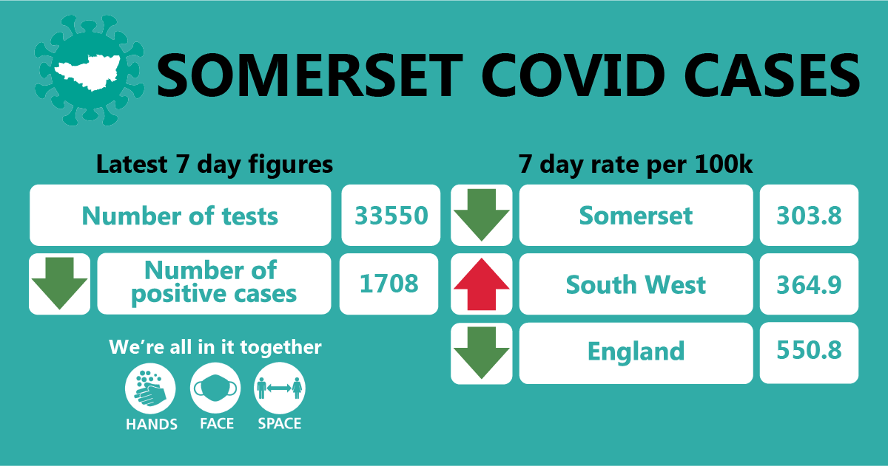

Between 05 and 11 January, approximately 33550 tests were carried out across the county and there has been 1708 new confirmed cases which is a decrease in the number of positive cases we saw in the week previous.
The link below shows the Somerset Dashboard which tracks our local epidemic from the start in March, to the current time:

https://www.somerset.gov.uk/covid-19-dashboard/

Workplaces: We continue to see outbreaks occurring as people socialise in and around the workplace (where people cannot work from home). While colleagues are typically following all the rules around social distancing, face coverings and handwashing at work in formal settings; we have seen multiple instances where colleagues are infected. This is happening because during breaks in staffrooms – more ‘informal settings,’ people are relaxed whilst enjoying their lunch or break and even at times making cups of tea for one another. These relaxations of the rules (however unintentionally) will cause the virus to spread so we must all continue to be vigilant. Please don’t share cups or cutlery, don’t make drinks for one another and continue measures such as hands face and space at all times.

Care Sector: In the seven days between 05 January and 11 January, there were 200 cases in 43 care settings. The positive cases identified were staff and residents within the settings, we continue to support these settings with support and guidance on prevention measures.

The vaccination programme is our number one priority and we are working incredibly hard to ensure that this moves forward at pace in our care settings. It is a complex process and there are many thousands of people across health and social care working extremely hard to get the vaccinations to all.

Schools and Early Years settings: The national lockdown means that only vulnerable children and those of key workers are able to attend school, with all other learning being conducted online.

Somerset schools are working hard to implement the Department for Education mass testing programme. This means staff and pupils in secondary and special schools will have access to rapid testing kits if they are on site

Communications:

Stay at home restrictions: We remain under a period of national lockdown, and as before, encourage you to share the following poster with your networks to help explain the restrictions: England Lockdown: Stay At Home posters - GOV.UK (www.gov.uk)
Somerset vaccination programme: Vaccinations are now being offered at 12 sites across Somerset – at ten GP-led community sites and at hospital hubs at Musgrove Park Hospital and at Yeovil District Hospital. Teams of vaccinators are also going into care homes. The programme is offering vaccinations to people in the high priority groups as identified by the Joint Committee on Vaccination and Immunisation. That is: care home residents and their carers, those aged 80 years of age and over and frontline health and social care workers.
To help keep telephone lines clear, particularly at GP surgeries, please help us to remind residents that they will be contacted by the NHS directly to arrange a vaccination appointment. Vaccinations are not available without an appointment.
For more information please visit: https://www.somersetccg.nhs.uk/health/local-services/health-services-during-coronavirus/covid-19-vaccinations-in-somerset/
This week’s Clinton Rogers’ Covid update film takes a closer look at the Somerset vaccination programme, and some of the great work going on behind the scenes by local council staff. You can watch it here: https://youtu.be/zt-9airOnR8

Be aware of vaccination scammers: Criminals are using the Covid-19 vaccine as a way to target the public by tricking them to hand over their cash or financial details. They are sending convincing looking text messages letting people know they are eligible for the vaccine or phoning people directly, pretending to be from the NHS, or a local pharmacy.
Please be alert to these scams. The NHS will:

NEVER ask for payment – the vaccine is free
NEVER ask for your bank details
NEVER arrive unannounced at your home to administer the vaccine
NEVER ask you to prove your identity by sending copies of personal documents such as your passport

There is more information on this attached with this document, please share.
The Cabinet Office has formed a Covid-19 Fraud Response Team to assist the government with its counter fraud response. Requests for assistance should be emailed to: covid19-counter-fraud@cabinetoffice.gov.uk

Mental Health Support: Next Monday 18 January, the third Monday in January, which is usually known as ‘Blue Monday’ will see the launch of The Samaritan’s ‘Brew Monday’ campaign. The aim is to turn this day on its head and create something positive by encouraging people to get together over a warming virtual ‘cuppa’.

Feeling alone with your problems can have a big impact on your mental health. So, this is about more than sharing a virtual drink together – it's about reaching out, checking in and staying connected. So if you can, please find a time on Monday to pause – maybe at the end of a meeting, or at lunch time, and check in with someone from your team, a friend or family member who you haven’t spoken to for a while. If you can’t do it this Monday it doesn’t matter. Find a time that suits you - just taking time to really listen to another person could help them work through what’s on their mind.

Its ok not to be ok – many of us may be feeling anxious, stressed, exhausted, concerned about a range of things. These are normal reactions to uncertainty and challenging events. Its ok to ask for help.

We regularly promote our coronavirus helpline (available from 8am until 6pm seven days a week on 0300 790 6275) and the Mindline emotional support helpline which is available 24/7 on 01823 276 892.

And as we mentioned last week, please do keep an eye our Healthy Somerset website, which has a huge amount of information and resources to help keep everyone healthy happy and safe at this time: https://www.healthysomerset.co.uk/covid-19/

Finally, please like us on Facebook, follow us on Twitter and share our posts with your networks to help us in communicating these important messages. Follow our Director of Public Health account too here.

Resources and further information: For the latest local information as well as digital resources, posters and flyers please visit: https://www.somerset.gov.uk/coronavirus/

The Somerset Local Outbreak Management Plan outlines how we, the council, will work with the NHS Test and Trace Service, PHE, the NHS and other partners to ensure a whole system approach to preventing and managing local outbreaks. This can be found here.

