This update is provided by the Somerset Covid-19 Engagement Board and is designed to provide a weekly update on the current Covid-19 situation in Somerset.
Thursday 7 January 2021
Somerset’s Covid-19 Weekly Update

Following an announcement by the Prime Minister on Monday night, Somerset, like the rest of England, is now under national lockdown. It was only last Thursday that we went into Tier 4, and we have not therefore seen the impact of those tougher restrictions reflected in our case rates.
We know that the highly contagious new variant of coronavirus is here in Somerset, and we also know that one in three people will carry the virus without displaying any symptoms at all. It is a very real and present threat to our health and to our NHS and care services, and we must all work together and make sure that this lockdown counts.
Ventilation is really important, so for those who cannot work at home, try to ensure that your workspace has fresh air, and open windows regularly. Keep two metres away from others, wear a mask correctly (it must fit snugly across your nose) wash your hands with soap and water for 20 seconds, and in between hand washing, use hand sanitiser. At a time where we may feel that there are many things we cannot do, these simple measures are within all of our control, and we must carry on with them.
‘Remember, everyone can catch it, anyone can spread it’.

Clare Paul, Cabinet Member for Public Health and Wellbeing
Twitter: @Clarepaul_

Trudi Grant
Director of Public Health
Twitter: @SomersetDPH

David Fothergill
Leader of
Somerset County Council
Twitter: @DJAFothergill
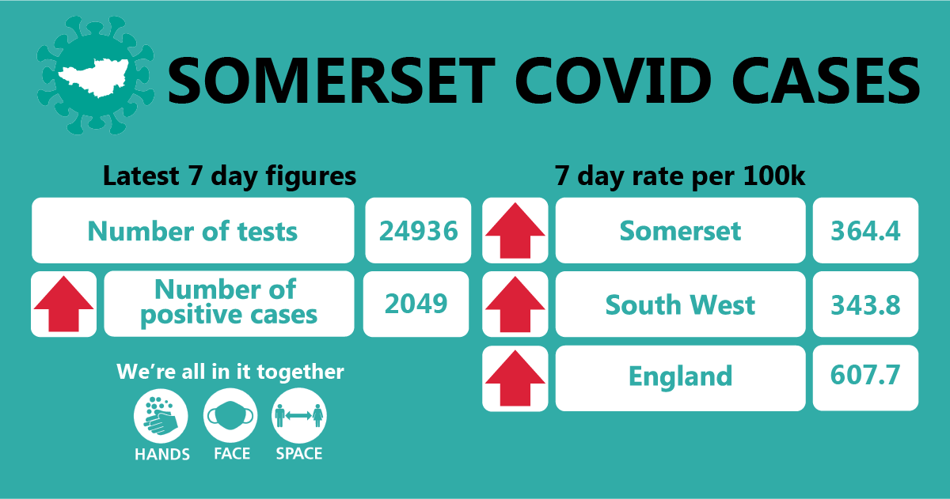
Somerset’s seven-day infection rate is now 364.4 new cases per 100,000, which is a large increase on last week’s figure of 248.3 cases per 100,000.
Between 28 December and 03 January, approximately 24936 tests were carried out across the county and there has been 2049 new confirmed cases.
The link below shows the Somerset Dashboard which tracks our local epidemic from the start in March, to the current time:

https://www.somerset.gov.uk/covid-19-dashboard/

Workplaces: We have identified a number of common themes and issues from outbreak investigations that employers should be aware of and action as appropriate. These are being shared through our business channels but are useful for everyone. They include:

- Staff in workplaces who are customer-facing are typically compliant with COVID-secure guidance while in their customer facing roles, but become less complacent when behind the scenes with colleagues, probably because we are often friends with our colleagues and don’t see them as a risk to us. Remember, that 30 per cent of positive cases do not display symptoms, and in people who do show symptoms, they are highly infectious for 48 hours before symptoms even show. So, it is essential to practice “hands, face, space” all the time. Breaks seem to be a particular issue, for example sitting together having lunch, smoking breaks, and drinks rounds.
- Staff coming to work against advice to isolate or when someone else in the household has symptoms. As soon as anyone shows symptoms in a household or tests positive, the whole household must isolate and get tested. Staff should not wait to isolate until they are tested or their test result is sent to them – do it straight away. Staff who are advised to isolate must do so. It is a criminal offence not to isolate if you have been instructed to do so by NHS Test and Trace or public health officials.
- It is an offence for an employer to knowingly allow a person who is required to self-isolate to work anywhere other than where they are self-isolating (normally their home). This applies when they are required to self-isolate following a positive test, or because they are a close contact of someone who has had a positive test, or they have been contacted by NHS Test and Trace or their local authority, or where they are required to quarantine after returning from abroad.
- It is important that staff are made aware of the support that is available while isolating.
https://www.gov.uk/guidance/coronavirus-covid-19-what-to-do-if-youre-employed-and-cannot-work#if-youre-off-work-because-you-have-coronavirus-symptoms-or-are-self-isolating-or-shielding

The Somerset Coronavirus Helpline on 0300 790 6275 is available to anyone who needs help while isolating, for example with food, medicines, walking the dog, isolation payments etc. No one should feel the need to break isolation for basic needs such as these. Help is available with one phone call.

Care Sector: In the seven days between 28 December and 03 January, there were 107 cases in 132 care settings. The positive cases identified were staff and residents within the settings, and we continue to support these settings with support and guidance on prevention measures.

Schools and Early Years settings: Since last week’s update, the national lockdown now means that only vulnerable children and those of key workers are able to attend school, and all other learning will be conducted online.

Somerset schools are working hard to implement the Department for Education mass testing programme. This means staff and pupils in secondary and special schools will have access to rapid testing kits if they are on site.

Communications:

Stay at home restrictions: As highlighted in the introduction, we are now in a national lockdown. A link to the poster detailing what this means can be found here: England Lockdown: Stay At Home posters - GOV.UK (www.gov.uk)

Please share this poster with your networks. Not only does it explain the restrictions, it also reminds us that the new strain of the virus is spreading fast.

This week’s Clinton Rogers Covid update film is an interview with Trudi about the new lockdown, and why it is so important that we all work together to make it count; particularly now we know that the new strain of the virus is present in Somerset. You can watch it here: https://www.youtube.com/watch?v=xU_dvvu8flI&feature=youtu.be

Importance of self-isolating correctly: Again, we drew your attention to this last week, and have already mentioned it in relation to workplace settings, but it is a vital part in helping to stop the spread of the virus. It is a legal requirement to self-isolate for the entire period of time (10 days from the day after you have symptoms or get a positive test result) if required to do so by NHS Track and Trace service or public health officials You must also self-isolate if you are a close contact of a confirmed case. Attached to this email are two graphics that illustrate the importance of this.

Please help us to remind everyone that if they develop symptoms, they MUST stay at home and self-isolate immediately. If they receive a positive test result but do not have symptoms, they must stay at home and self-isolate as they receive the result. Their entire household needs to isolate too. This means: do not go to work, school, or public areas and do not use public transport or taxis.

To help people understand this critical step in containing the spread of the virus, we continue to promote it on our social media channels. Here is an example:

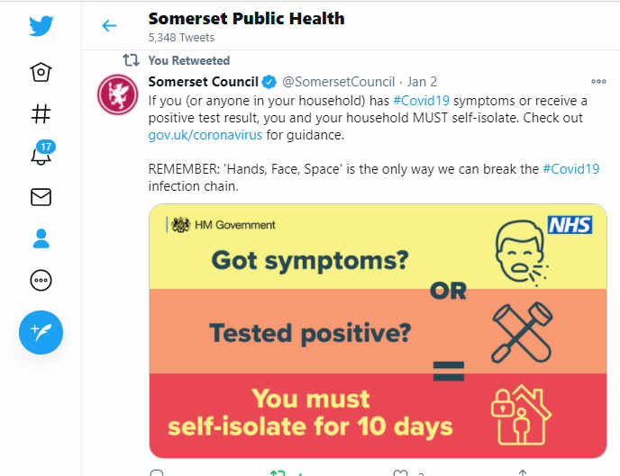

As with all of our social media posts on Twitter and Facebook, please share them with your networks to help us get these important messages to as wide an audience as possible.

Support for residents: We know that lockdown is very hard, and even more so without the beautiful weather that we had last Spring. So, we are increasing the messaging to our residents about the support available to them. This includes, but not exclusively: those experiencing domestic abuse, people who are clinically extremely vulnerable and shielding, anyone experiencing mental health difficulties, including alcohol abuse, people having to self-isolate, and of course parents who are now facing the prospect of home schooling their children.

We also regularly promote our coronavirus helpline (available from 8am until 6pm seven days a week on 0300 790 6275) and the Mind emotional support helpline which is available 24/7 on 01823 276 892.

In the coming weeks, while we will continue to promote these sources of help for our residents, we will also be focusing on what we CAN all do during lockdown to keep ourselves safe and well, both physically and mentally. This will be important and hopefully empowering for everyone, when so much of what we hear is about what we cannot do during the lockdown. Our Healthy Somerset website has a huge amount of information and resources to help keep everyone healthy happy and safe at this time: https://www.healthysomerset.co.uk/covid-19/

We will also be seeking input from our Health and Wellbeing Advisory Network. This Network will help us to understand the Covid-19 related communication and engagement needs of our communities across Somerset and is made up of a range of individuals from organisations and community groups. It will allow both preventative and reactive conversations with a number of settings and groups where an outbreak of Covid-19 is likely to have adverse health consequences. If you are not a member but represent a community group or organisation that would like to help support our communications, please sign up here.

Coronavirus test centres: On 5, 10 and 11 January, a Covid-19 Mobile Testing Unit will be present at Winchester Farm in Cheddar. Full details are available on our social media pages – add link to FB?

As we continue to make testing more accessible to areas with acute need, we would like to remind everyone that in order to get a test, people MUST book in advance, and tests are only available for those with coronavirus symptoms – a high temperature, a new continuous cough, or a loss or change to sense of smell or taste. Anyone with one or more of these symptoms should book a test at nhs.uk/coronavirus or by calling 119. Please do not turn up at the testing centres without booking an appointment.
Currently there are regional testing sites located at Taunton Racecourse, Exeter and Bristol, a walk-through testing unit at Bridgwater Town Hall and Mobile Test Unit sites at Frome Cricket Club, Victoria Club Street and Westlands Centre Yeovil, Weston-super-Mare, Warminster, Cullompton, Dorchester and Bridport. Barnstaple and Trowbridge have also recently opened walk-through local testing sites.

Finally, please like us on Facebook, follow us on Twitter and share our posts with your networks to help us in communicating these important messages. Follow our Director of Public Health account too here.

Resources and further information: For the latest local information as well as digital resources, posters and flyers please visit: https://www.somerset.gov.uk/coronavirus/

The Somerset Local Outbreak Management Plan outlines how we, the council, will work with the NHS Test and Trace Service, PHE, the NHS and other partners to ensure a whole system approach to preventing and managing local outbreaks. This can be found here.

