This update is provided by the Somerset Covid-19 Engagement Board and is designed to provide a weekly update on the current Covid-19 situation in Somerset.
Thursday 31 December 2020
Somerset’s Covid-19 Weekly Update

Following an announcement by the Health Secretary Matt Hancock yesterday, Somerset is now in tier 4 – Stay at Home. While we know how tough tier 4 restrictions are for so many, they are now necessary in order for us to halt the very sharp rise in our cases, which have increased by more than a third (37 per cent) since before Christmas. We know that the new variant of coronavirus is here in the South West, and it is far more transmissible, therefore the simple messages of keeping your distance from others, washing your hands with soap and water for 20 seconds, and wearing a face covering, have never been more important.
Our NHS colleagues are currently coping with the additional pressure they are facing, but the impact of people mixing on Christmas Day, will undoubtedly add to our cases in the coming weeks, and sadly, some of those cases will result in hospital admissions. We need to all work together to protect our NHS.
Yesterday also saw the approval for use in the UK of the new Oxford AstraZeneca coronavirus vaccine. This will start to roll out from next week, so the vaccination programme in Somerset will soon gather pace. This is without doubt great news, but it is not a reason for anyone to relax our guard while our cases numbers are increasing so rapidly. Tonight, we see in 2021, and while we will be relieved to say goodbye to such a difficult year, we must be patient for a little while longer. So, only celebrate tonight with your immediate household or support bubble, and in the next few weeks, treat everyone as if they have the virus, and please follow the tier 4 restrictions.
‘Remember, everyone can catch it, anyone can spread it’.

Clare Paul, Cabinet Member for Public Health and Wellbeing
Twitter: @Clarepaul_

Trudi Grant
Director of Public Health
Twitter: @SomersetDPH

David Fothergill
Leader of
Somerset County Council
Twitter: @DJAFothergill

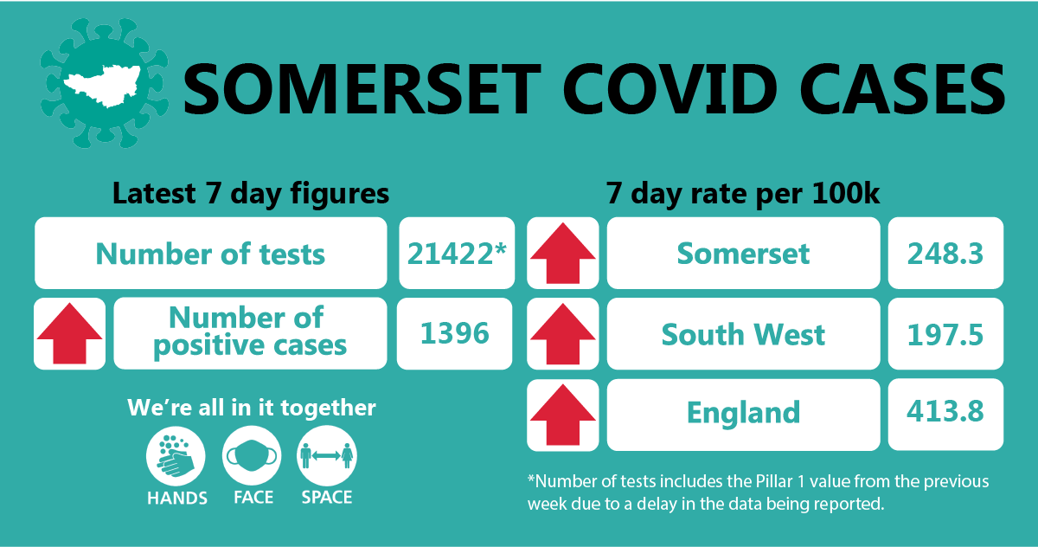

- Somerset’s seven-day infection rate is now 248.3 new cases per 100,000, which is a sharp increase. The rate of new cases over the past four weeks has almost trebled (2.75x higher).in the most recent week the rate of new cases has continued to increase by over a third (37%).
Between 21 December and 27 December, approximately 21422 tests were carried out across the county and there has been 1396 new confirmed cases.
The link below shows the Somerset Dashboard which tracks our local epidemic from the start in March, to the current time:

https://www.somerset.gov.uk/covid-19-dashboard/

Workplaces: Unfortunately, we have seen a sharp increase in the number of outbreaks occurring in workplaces (where people cannot work from home). While people are typically following all the rules around social distancing, face coverings and handwashing while working, we continue to see spread among colleagues due to them relaxing together during lunch or break times. When in the company of colleagues, who are often friends as well, it is easier to forget the need to keep a safe distance, but it is vitally important to do so. If you treat everyone as if they carry the virus, including colleagues and friends, it will help to prevent the spread that we are currently seeing across workplaces.

Care Sector: In the seven days between 21 – 27 December, there were 97 cases in 15 care homes. The positive cases identified were staff and residents within the settings, we continue to support these settings with support and guidance on prevention measures.
Vaccinations in Somerset care homes began in the week beginning 28 December.
Schools and Early Years settings: We are still in the Christmas holiday period for schools, however in the seven days between 21-27 December, 46 cases were identified in 12 schools and nine cases in two nursery settings.

Primary schools will be returning as planned on 4 January, and secondary pupils in exam years will return on 11 January, with the remaining secondary pupils following on 18 January.

We continue to support all educational settings with both the prevention and mitigation of coronavirus within their school communities and continue to be impressed with how they are responding to outbreaks. We will update you further regarding testing in secondary schools next week.

Communications:

New Tier restrictions: As highlighted in the introduction, Somerset is now under tier 4 restrictions. A link to the poster detailing what this means can be found here: COVID-19_Tier_Posters_16_December_2020_04.pdf (publishing.service.gov.uk)

Please do share this poster with your networks. Not only does it explain the restrictions, it also reminds us that one in three people carrying the virus have no symptoms. This is an important message that we are promoting on our social media channels, and it is why we suggest treating everyone as if they might have the virus.

New Year’s Eve: Again, as explained in the introduction, it is vital that people stick to the rules, including tonight where we would usually see friends and family and celebrate the start of the new year together. Under tier 4 restrictions, you are only allowed to celebrate with your household or support bubble, and we are reminding people of this on our social media and in the latest video from Clinton Rogers which can be found here: Somerset Covid catch up week 4, 31 Dec 2020 - YouTube

Importance of self-isolating correctly: It is a legal requirement to self-isolate for the entire period of time (10 days from the day after you have symptoms or get a positive test result) if required to do so by NHS Track and Trace service.

Please help us to remind everyone that if they develop symptoms, they MUST stay at home and self-isolate immediately. If they receive a positive test result but do not have symptoms, they must stay at home and self-isolate as they receive the result. Their entire household needs to isolate too. This means: do not go to work, school, or public areas and do not use public transport or taxis.

To help people understand this vital step in containing the spread of the virus, we are again promoting our ‘Jane’ incubation and isolation graphic, and social media posts from PHE. The graphic is attached to this email. As with all of our social media posts, please share them with your networks to help us get these important messages to as wide an audience as possible.
Roll out of the vaccination programme in Somerset so far: On 06 December Yeovil District Hospital (YDH) was announced as one of the first 50 hospital hubs to receive supplies of vaccine and vaccinations at the hospital began in the week beginning 07 December.
At the start of the week beginning 14 December, vaccinations began at four GP-led sites developed by primary care networks (groups of local GP practices) who have worked closely together to develop detailed plans to deliver Covid-19 vaccinations in community locations. The first four GP-led sites where patients received vaccinations were at Taunton Vale Healthcare, Taunton; The Mulberry Centre, Berrow; West Mendip Community Hospital, Glastonbury; and The Gateway Centre in Yeovil.
Towards the end of the week beginning 14 December, vaccinations also began at three further GP-led sites - at Frome Medical Centre, Minehead Community Hospital and the Henhayes Community Centre, in Crewkerne.
Vaccinations began at two further GP-led sites – at Mendip District Council Offices and North Petherton Rugby Club in the week beginning 28 December.
These sites have worked through the complicated logistics required to deliver the vaccine safely in a suitable environment. This involves ensuring they have all of the kit needed including clinical supplies, IT equipment, printed patient leaflets and bins; that there is a range of colleagues on hand to greet patients, explain the vaccine to them and take informed consent, draw up the vaccine, administer it and record it; and ensuring that all these site can be appropriately managed, including considering a range of aspects including infection prevention and control, cleaning and appropriate traffic management. It is a huge undertaking.
Would you like to be a Covid Community Champion? Are you chatty and friendly? Do you want to help people to stay safe during the Covid-19 pandemic? Join our growing team of Covid Community Champions! We don't want much of your time...the aim of the programme is to help our residents get clear information on how to stay safe and reduce the risk of getting and spreading coronavirus.

After attending a short online training course, Covid Community Champions will be able to help their family, friends and the wider community to understand the latest guidance around Covid-19, and signpost to other health and wellbeing support. This can be done informally as the Champions go about their day to day lives. Whether they chat to someone while queuing outside the shop, talk to colleagues at work, or challenge something they see online, they will play a vital part in helping keep local people informed, happy and healthy.

To register your interest in becoming a Covid Community Champion, sign up here.

The Covid Community Champions scheme is funded by Somerset County Council’s Public Health and delivered by a partnership between Spark Somerset and the Somerset Activity and Sports Partnership (SASP).

Finally, please like us on Facebook, follow us on Twitter and share our posts with your networks to help us in communicating these important messages. Follow our Director of Public Health account too here.

Resources and further information: For the latest local information as well as digital resources, posters and flyers please visit: https://www.somerset.gov.uk/coronavirus/
For information and resources on staying healthy happy and safe at the time please visit: https://www.healthysomerset.co.uk/covid-19/

The Somerset Local Outbreak Management Plan outlines how we, the council, will work with the NHS Test and Trace Service, PHE, the NHS and other partners to ensure a whole system approach to preventing and managing local outbreaks. This can be found here.

