This update is provided by the Somerset Covid-19 Engagement Board and is designed to provide a weekly update on the current Covid-19 situation in Somerset.
Thursday 17 December 2020
Somerset’s Covid-19 Weekly Update

Over-arching message: After the Prime Minister’s latest announcement, we know that Somerset currently remains in Tier 2; it’s vital we all follow these rules in the run up to Christmas as mistakes now, could prove very costly in the future. With Christmas fast approaching we would like to remind you all that whilst you can bubble with two other households – making a maximum of three families between 23 and 27 December, you should think really carefully about the risks involved in this. The latest guidance from Government is to keep Christmas ‘Short, Small and Local’. We would urge you to really heed this advice as our actions now will inevitably impact our case numbers in the weeks to come.
Of course, we want everyone to have a very Happy Christmas, but when you do spend time with people outside your household, try to remember that this virus is very resilient – it sticks to objects making it easy to spread. When passing items whilst celebrating with family, whether that be presents, playing board games or passing the gravy boat on Christmas Day; please remember to wash hands frequently and keep hand sanitiser close by – it really will help.

‘Remember, everyone can catch it, anyone can spread it’.

Clare Paul, Cabinet Member for Public Health and Wellbeing
Twitter: @Clarepaul_

Trudi Grant
Director of Public Health
Twitter: @SomersetDPH

David Fothergill
Leader of
Somerset County Council
Twitter: @DJAFothergill

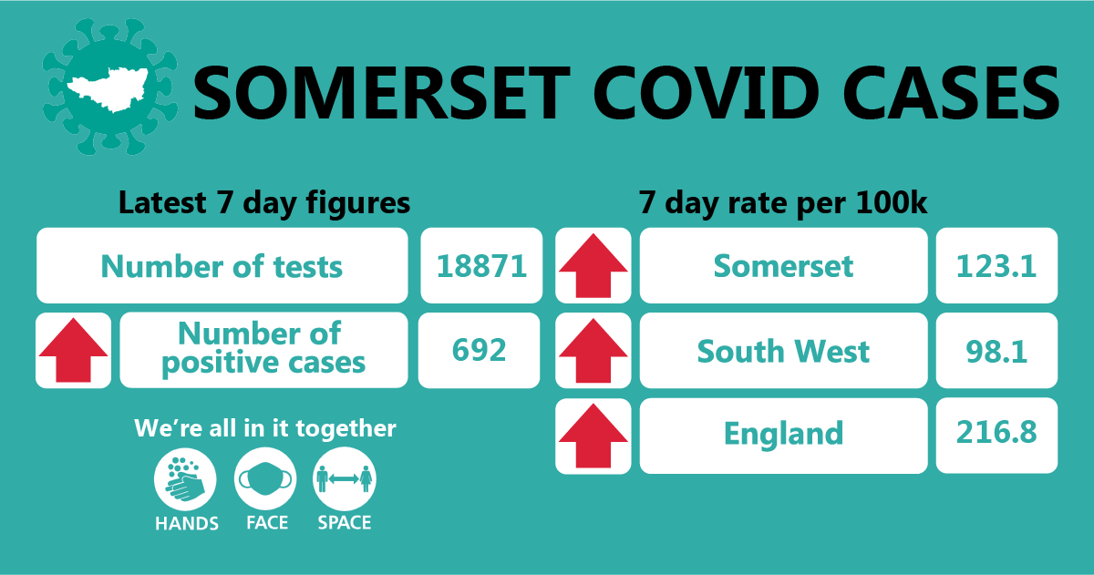

Cases and testing: Somerset’s seven-day infection rate is now 123.1 new cases per 100,000, this is a sharp rise on last week’s rate of 86.8. Between 7 December and 13 December, 18,871 tests were carried out across the county and there has been 692 new confirmed cases in the county – an increase on the last reported case numbers.

The rise we are seeing undoubtably coincides with the end of the second ‘lockdown’ so it is vital that the continued Tier 2 restrictions and guidelines are adhered to and followed to help us bring these numbers back down.
The link below shows the Somerset Dashboard which tracks our local epidemic from the start in March, to the current time:

https://www.somerset.gov.uk/covid-19-dashboard/

Workplaces: We continue to see outbreaks occurring as people socialise in and around the workplace (where people cannot work from home). While colleagues are typically following all the rules around social distancing, face coverings and handwashing at work; we have seen multiple instances where colleagues are infected. This is happening because people are relaxed when in the company of colleagues, often friends, and having lunch or a break together, but not distancing.

Care Sector: In the seven days between 10 – 17 December, there were 16 cases in 8 care homes which is a reduction on the previous week. The positive cases identified were staff and residents within the settings, we continue to support these settings with support and guidance on prevention measures.

Amongst the highest priority groups to receive the vaccine, are care home staff. By vaccinating staff, we aim to help protect individuals from becoming unwell with, or dying from, Covid-19 disease. Rollout of vaccinations for care staff has started this week.
Schools and Early Years settings: We are continuing to see confirmed cases of coronavirus in staff and students across our educational settings. In the seven days between 10-17 December, 29 cases were identified in 17 schools and 2 cases in two nursery settings, this is an increase on the following week.

We continue to support all educational settings with both the prevention and mitigation of coronavirus within their school communities and continue to be impressed with how they are responding to outbreaks. We wish them all a happy and safe Christmas break.

Communications: As our case numbers continue to rise it is important - perhaps more now than ever before - that we do all we can to protect ourselves and others. It will be some time until the vaccine has been administered to all of us and until that time the virus will still be circulating in our communities.

Where possible, people are being encouraged to keep their Christmas celebrations small, short, and local as well as thinking about the vulnerable.

In the lead up to Christmas and over festive period, people should continue to follow the hands, space, face guidance, and self-isolate if they show symptoms of coronavirus which include a high temperature, a new continuous cough, or a loss or change to their sense of smell or taste.

Covid-19 vaccination – local sites announced: This week, the very first local sites have started vaccinating some of the county’s most vulnerable residents. People who have been identified by the Joint Committee on Vaccination and Immunisation (JCVI) as the highest priority will be invited first, including over-80s and health and care staff.
This first wave of community GP-led sites follows the launch of the NHS vaccination programme in hospital hubs, such as Yeovil District Hospital, and is part of a range of ways that people will access vaccination services across Somerset.
Vaccinations will initially be delivered from four different sites in Somerset including Taunton Vale Healthcare, Taunton; The Mulberry Centre, Berrow; West Mendip Community Hospital, Glastonbury; and The Gateway Centre in Yeovil. These initial GP-led sites have been developed by primary care networks (groups of local GP practices) who have been working closely together to develop detailed plans to deliver COVID-19 vaccinations in community locations.
Would you like to be a Covid Community Champion? Are you chatty and friendly? Do you want to help people to stay safe during the Covid-19 pandemic? Join our growing team of Covid Community Champions! We don't want much of your time...the aim of the programme is to help our residents get clear information on how to stay safe and reduce the risk of getting and spreading coronavirus.

After attending a short online training course, Covid Community Champions will be able to help their family, friends and the wider community to understand the latest guidance around Covid-19, and signpost to other health and wellbeing support. This can be done informally as the Champions go about their day to day lives. Whether they chat to someone while queuing outside the shop, talk to colleagues at work, or challenge something they see online, they will play a vital part in helping keep local people informed, happy and healthy.

To register your interest in becoming a Covid Community Champion, sign up here.

The Covid Community Champions scheme is funded by Somerset County Council’s Public Health and delivered by a partnership between Spark Somerset and the Somerset Activity and Sports Partnership (SASP).

Finally, please like us on Facebook, follow us on Twitter and share our posts with your networks to help us in communicating these important messages. Follow our Director of Public Health account too here.

Resources and further information: For the latest local information as well as digital resources, posters and flyers please visit: https://www.somerset.gov.uk/coronavirus/
For information and resources on staying healthy happy and safe at the time please visit: https://www.healthysomerset.co.uk/covid-19/

The Somerset Local Outbreak Management Plan outlines how we, the council, will work with the NHS Test and Trace Service, PHE, the NHS and other partners to ensure a whole system approach to preventing and managing local outbreaks. This can be found here.

