This update is provided by the Somerset Covid-19 Engagement Board and is designed to provide a weekly update on the current Covid-19 situation in Somerset.
Thursday 10 December 2020
Somerset’s Covid-19 Weekly Update
Over-arching message: This week marks the rollout of covid-19 vaccinations to priority groups in Somerset, with Yeovil Hospital being the first setting in Somerset to start vaccinating these people against covid-19.
This is a real turning point in our fight against the disease, however, even with the very welcome news of this vaccination rollout, we can’t afford to drop our guard; until we are all able to get vaccinated against covid-19, it still poses a very real risk in our communities. Whilst many more shops and businesses are now open, we know how tempting it is to go out and about but please, think carefully when you do so. Some stores have extended their opening hours which we would encourage people to make use of in order to try to shop at times when stores might be quieter.
We must all continue to follow the guidelines, particularly in the lead up to Christmas when we will be spending time with loved ones. If we change the people, change the faces, then the risk of spreading the virus goes up – for us - and to them.

‘Remember, everyone can catch it, anyone can spread it’.

Clare Paul, Cabinet Member for Public Health and Wellbeing
Twitter: @Clarepaul_

Trudi Grant
Director of Public Health
Twitter: @SomersetDPH

David Fothergill
Leader of
Somerset County Council
Twitter: @DJAFothergill

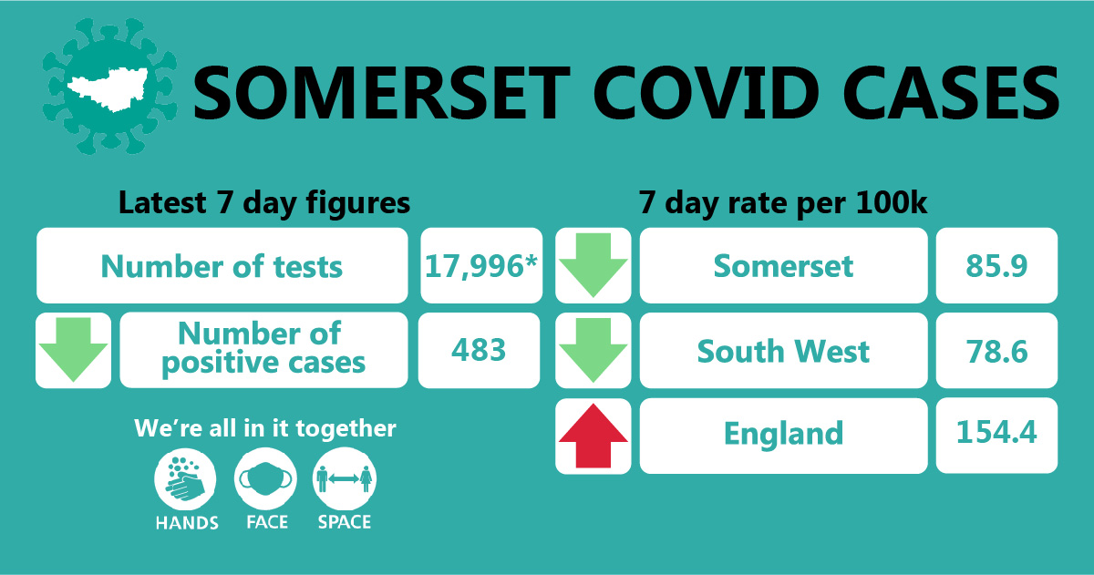

Cases and Testing: Somerset’s seven-day infection rate is now 85.9 new cases per 100,000. Between 30 November and 6 December there has been 483 new confirmed cases in the county – a reduction on the last reported case numbers. *Pillar 1 testing (testing carried out in PHE labs and NHS hospital settings) for the last week has not been made available yet due to upgrades being made by NHS England – this figure represents the pillar 1 testing for the week up to the 1st December.

We are seeing rates across the county begin to plateau however Somerset’s rate remains higher than some other areas in the South West.
The link below shows the Somerset Dashboard which tracks our local epidemic from the start in March, to the current time:

https://www.somerset.gov.uk/covid-19-dashboard/

Workplaces: We continue to see outbreaks occurring as people socialise in and around the workplace (where people cannot work from home). While colleagues are typically following all the rules around social distancing, face coverings and handwashing at work; we have seen multiple instances where colleagues are infected. This is happening because people are relaxed when in the company of colleagues, often friends, and having lunch or a break together, but not distancing.

Care Sector: In the seven days between 3rd – 10th December, there were 26 cases in 15 care homes. The positive cases identified were staff and residents within the settings, we continue to support these settings with support and guidance on prevention measures.

Amongst the highest priority groups to receive the vaccine, are care home staff. By vaccinating staff, we aim to help protect individuals from becoming unwell with, or dying from, Covid-19 disease. Rollout of vaccinations for care home staff will start from next week.
Some of our care homes have started to receive Lateral Flow Device (LFD) test kits; all care homes in the county will be sent Lateral Flow Device (LFD) test kits by 18 December. These produce results very quickly, within 30 minutes. Care homes will receive these tests in addition to the regular tests that are already sent for weekly staff and monthly resident testing. These LFD tests will be able to be used for scheduled visitor testing.
Schools and Early Years Settings: We are continuing to see confirmed cases of coronavirus in staff and students across our educational settings. In the seven days between 3rd – 10th December, 24 cases were identified in 17 schools and 2 cases in one nursery setting

With the limited freedoms granted to us under tier 2 restrictions, it is more important than ever that we all continue to follow national and local guidance. This will help us to keep as many children and young people in school for as long as possible and as safely as possible. We continue to support all educational settings with both the prevention and mitigation of coronavirus within their school community.

Communications: Our focus on communications is to ensure that people do not become complacent now that a covid-19 vaccine is being rolled out, this a marathon not a sprint and we still have a way to go before we will get back to some kind of normality.
We are asking people to please be patient; this is the first phase of vaccinations and the NHS will get in touch when it’s your turn to be vaccinated.

We continue to promote the importance of adhering to new tier 2 guidelines, in particular travelling between tiers; you must stick to the advice of only making journeys for essential reasons, and travel to Tier 3 areas is particularly advised against.

Once you are in another tier, you should stick to the guidance of your own tier if you have come from a higher one, or act under the guidance of the higher tier if you are ‘moving up’ into it.

Somerset’s Covid Catch Up: The second instalment of our Somerset Covid Catch up, presented by former BBC television journalist Clinton Rogers, focusses on the rollout of the vaccination programme in Somerset. Clinton interviews Chief Nurse Shelagh Meldrum who urges people to be patient and reminds people that there is a risk-based prioritisation for the rollout and that people will be called when it’s their turn for the vaccination.

The former BBC Points West correspondent will front the new series which aims to help people understand how Covid-19 is affecting Somerset, and what we can all be doing to help beat the virus.
The weekly Covid Catch Up videos will give valuable information and advice, and Somerset County Council is encouraging viewers to send in their questions, so that they can be answered in the next film. Watch the video here.

Would you like to be a Covid Community Champion? Are you chatty and friendly? Do you want to help people to stay safe during the Covid-19 pandemic? Join our growing team of Covid Community champions! We don't want much of your time...the aim of the programme is to help our residents get clear information on how to stay safe and reduce the risk of getting and spreading coronavirus.

After attending a short online training course, Covid Community Champions will be able to help their family, friends and the wider community to understand the latest guidance around Covid-19, and signpost to other health and wellbeing support. This can be done informally as the Champions go about their day to day lives. Whether they chat to someone while queuing outside the shop, talk to colleagues at work, or challenge something they see online, they will play a vital part in helping keep local people informed, happy and healthy.

To register your interest in becoming a Covid Community Champion, sign up here.

The Covid Community Champions scheme is funded by Somerset County Council’s Public Health and delivered by a partnership between Spark Somerset and the Somerset Activity and Sports Partnership (SASP).

Somerset’s Health and Wellbeing Advisory Network: The Health and Wellbeing Advisory Network has been set up to help us to understand the COVID related communication and engagement needs of our communities across Somerset. The Network will feedback to the Covid-19 Engagement Board and the Health and Wellbeing Board to help shape our response to the pandemic. The idea is to make communicating and engaging with groups and settings more targeted, simpler and with a joined-up approach.

It will made up of a range of individuals from organisations and community groups and will allow both preventative and reactive conversations with a number of settings and groups where an outbreak of Covid-19 is likely to have adverse health consequences. By joining, you can expect to receive regular up to date information on covid-19 and health impacts across Somerset, opportunities to feedback to us via surveys and citizens panels as well as exclusive access to webinars and communications materials to address specific issues and barriers locally. If you represent a group/setting or community in Somerset, please sign up by simply clicking here, enter your name and email address and we will be in touch.

Resources and Further Information: For the latest local information as well as digital resources, posters and flyers please visit: https://www.somerset.gov.uk/coronavirus/
For information and resources on staying healthy happy and safe at the time please visit: https://www.healthysomerset.co.uk/covid-19/

The Somerset Local Outbreak Management Plan outlines how we, the council, will work with the NHS Test and Trace Service, PHE, the NHS and other partners to ensure a whole system approach to preventing and managing local outbreaks. This can be found here.

