This update is provided by the Somerset Covid-19 Engagement Board and is designed to provide a weekly update on the current Covid-19 situation in Somerset.
Friday 27 November 2020
Somerset’s Covid-19 Weekly Update
Over-arching message: As Government announced that Somerset will be placed in Tier 2 when national restrictions end on 2 December, we need to make sure all our efforts and sacrifices now stick and our rates don’t go shooting back up again. In order to enjoy Christmas safely with our loved ones, we must be really careful over the next few weeks.
We all need to adhere to the rules for Tier 2 in the lead up to Christmas and during the festive season. The all-important behaviours of Hands – Face – Space and isolating if you have symptoms are crucial.
Now is the time for everyone to act responsibly for two reasons. Firstly, if we all reduce our risk now, we reduce the chance of catching the virus and missing out on Christmas together due to having to self-isolate. Secondly, and importantly, if we reduce our own personal risk now, we reduce the risk of passing the virus on to any family or vulnerable people we may spend time with in the coming weeks. Now is the time for restraint and to act responsibly.
‘Remember, everyone can catch it, anyone can spread it’.

Clare Paul, Cabinet Member for Public Health and Wellbeing
Twitter: @Clarepaul_

Trudi Grant
Director of Public Health
Twitter: @SomersetDPH

David Fothergill
Leader of
Somerset County Council
Twitter: @DJAFothergill

Testing and cases: We are starting to see rates plateau with a notable drop in Somerset’s seven-day rate per 100,000. Let’s continue to work together to follow the guidance and bring these rates down even lower.
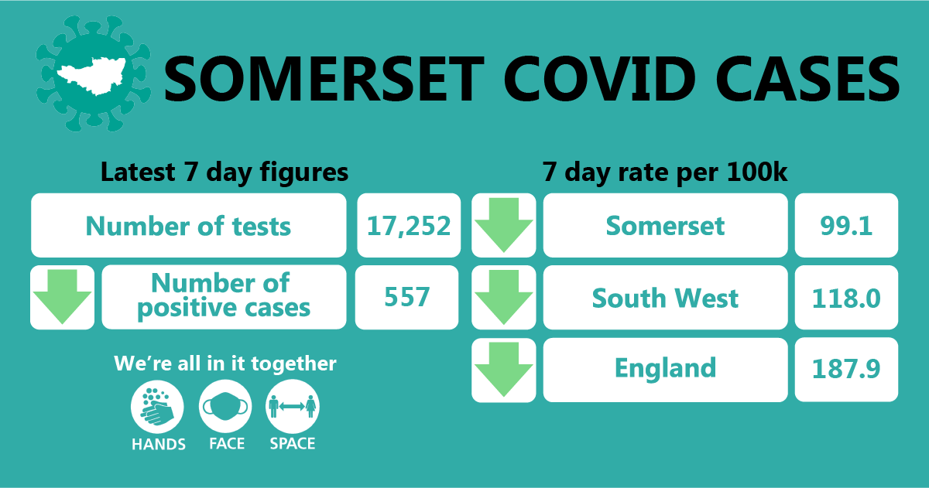

Somerset’s seven-day infection rate is now 99.1 new cases per 100,000. Between 17- 23 November, 17,252 tests were carried out and during these dates, at the time of writing, there have been 557 new confirmed cases in the county.

Looking across the districts in Somerset, at the time of writing, rates are currently highest in Mendip (138.4 cases per 100,000) and Sedgemoor (115.3 cases per 100,000). However, Sedgemoor’s rate has decreased in the last week from 174.5.

The link below shows the Somerset Dashboard which tracks our local epidemic from the start in March, to the current time:

https://www.somerset.gov.uk/covid-19-dashboard/

Workplaces: We continue to see outbreaks occurring as people socialise in and around the workplace (where people cannot work from home). While colleagues are typically following all the rules around social distancing, face coverings and handwashing at work, we have now seen multiple instances where colleagues are infected. This is happening because people are relaxed when in the company of colleagues, often friends, and having lunch or a break together, but not distancing.

Chatting together over a table or in a group while you eat with people from outside your household or household bubble and not distancing is a risk, because you cannot know if someone has Covid-19 – they could be either asymptomatic (not displaying symptoms) or pre-symptomatic (about to become show symptoms). People who are pre-symptomatic are highly infectious for about 48 hours (2 days) before they show symptoms. The risks are considerably higher in enclosed rooms with poor ventilation.

So, our advice is to treat anyone from outside your household as potentially infected with Covid-19 and keep your distance.

Care Sector: In the seven days between 20-26th November, 26 care homes have had a least one case.

We are seeing a significant number of cases in our care homes amongst staff and residents. Somerset County Councils Public Health and partners continue to support care settings by undertaking risk assessments, providing advice and giving support and guidance on infection prevention control and what to do if someone starts to show symptoms or tests positive.

We are reminding care homes and visitors that we must take extra measures to keep our care home residents safe. In accordance with the new national tiers, Somerset is in tier 2 and therefore care home visiting will be paused until the roll out of rapid testing is in place. The first care homes in Somerset should be receiving their delivery of lateral flow testing kits this week with other care settings across the county receiving theirs over the next two weeks.

We do very much appreciate the difficult situation that this creates and the impact this will have in the short term but must consider resident safety as the number one priority.

Schools and Early Years Settings: We continue to support all educational settings with both the prevention and mitigation of coronavirus within their school community.

We are seeing confirmed cases of coronavirus in staff and students and as Somerset moves into Tier 2 restrictions on the 2 December, it is more important than ever that we all continue to follow national and local guidance. This will help us to keep as many children and young people in school for as long as possible and as safely as possible.

In the seven days between 20-26th November, 31 schools and 6 nurseries have had a least one case.

Information for parents, carers and guardians:
- New COVID Checker for parents: https://www.cypsomersethealth.org/resources/covidchecker-schools_V2.pdf
- Resources for parents to understand the difference between a cold and Covid-19: https://www.healthysomerset.co.uk/covid-19/info/ipc/
- School self-isolation guidance:
https://www.healthysomerset.co.uk/wp-content/uploads/2020/04/School-Self-Isolation-Guidance-1.pdf

Communications: Our focus on communications is on ensuring that people understand the importance of adhering to new tier 2 guidelines after 2 December. How people choose to act after national restrictions come to an end, could impact the time that can be spent with loved ones at Christmas.
We will be working with our colleagues in Avon and Somerset Police, District Councils and the NHS to ensure that we do all we can to protect our residents over this next period. This includes urging people from higher tiers to think carefully before visiting Somerset and strictly adhering to the guidance if they do visit. We will be reminding people of the guidance around travelling in between tiers; in particular, sticking to the guidelines that have been set for their tier they live.

Somerset to be in ‘Tier 2’ from 2 December: Government announced yesterday (26 Nov) that Somerset would be placed into ’Tier 2’ after national restrictions end on 2 December. This covers all four districts – Mendip, Sedgemoor, South Somerset and Somerset West and Taunton – the area covered by Somerset County Council.

In tier 2 the headline rules include:
- Meeting friends and family: no mixing of households indoors, apart from support bubbles. Maximum of six outdoors.
- Bars, pubs and restaurants: pubs and bars must close, unless operating as restaurants. Hospitality venues can only serve alcohol with substantial meals. Venues must stop taking orders at 10pm and must close by 11pm.
- Retail: open.
- Work and business: everyone who can work from home should do so.
- Education early years settings, schools, colleges and universities open. Childcare, other supervised activities for children, and childcare bubbles permitted.
- Indoor leisure: open.
- Accommodation: open.
- Personal care: open.
- Overnight stays: permitted with household or support bubble.
- Weddings and funerals: 15 guests for weddings, civil partnerships, wedding receptions and wakes; 30 for funerals.
- Entertainment: open.
- Places of worship: open but cannot interact with anyone outside household or support bubble.
- Travelling: reduce the number of journeys you make and walk or cycle if possible. Avoid busy times and routes on public transport. Avoid car sharing with those outside of your household or support bubble. Avoid travelling outside your area, or entering a tier 3 area, other than where necessary such as for work or education. Further exemptions apply.
- Exercise: classes and organised adult sport can take place outdoors but cannot take place indoors if there is any interaction between people from different households. Organised activities for elite athletes, under18s and disabled people can continue.
- Residential care: covid-secure arrangements such as substantial screens, visiting pods, and window visits. Outdoor/airtight visits only (rollout of rapid testing will enable indoor visits including contact).
- Large events: sport, live performances and business meetings limited to 50% capacity or 2000 people outdoors (whichever is lower) and 50% capacity or 1000 people indoors (whichever is lower)

Full details can be found here: Find out the coronavirus restrictions in your local area - GOV.UK (www.gov.uk)

Christmas Guidelines: This week, Government announced that up to three households will be able to meet up during a five-day Christmas period of 23 to 27 December, leaders of the four UK nations have agreed.

People can mix in homes, places of worship and outdoor spaces, and travel restrictions will also be eased but a formed ‘Christmas bubble’ must be exclusive.

The main points to be aware of are:
- You can travel between tiers and UK nations to and from your Christmas bubble between 23rd and 27th December.
- Once at your destination you should follow rules in that tier.
- Three households can form a Christmas bubble together.
- You can only be in one Christmas bubble.
- You cannot change your Christmas bubble.
- You can only meet your Christmas bubble in private homes or in your garden, places of worship, or public outdoor spaces.
- You can continue to meet people who are not in your Christmas bubble outside your home according to the rules in the tier where you are staying.
- If someone is in your Christmas bubble, you can visit each other’s homes and stay overnight.

Relevant documents:
- Guidance: Making a Christmas bubble with friends and family: https://www.gov.uk/government/publications/making-a-christmas-bubble-with-friends-and-family/making-a-christmas-bubble-with-friends-and-family
- Joint statement on UK-wide Christmas arrangements from the UK Government and Devolved Administrations: https://www.gov.uk/government/news/joint-statement-on-uk-wide-christmas-arrangements-from-the-uk-government-and-devolved-administrations
- Student movement and plans for the end of term: https://www.gov.uk/government/publications/higher-education-reopening-buildings-and-campuses/student-movement-and-plans-for-the-end-of-autumn-2020-term
- Local restriction tiers: what you need to know: https://www.gov.uk/guidance/local-restriction-tiers-what-you-need-to-know

Understanding Self Isolation Guidelines: You can be asked to isolate at home for 14 days if you have been identified as a close contact of a positive case.

If one member of a household gets a positive test result, everyone in the household must isolate as they would likely be deemed as ‘close contacts’ of the confirmed case. How long each member would need to isolate for, can vary based on a number of scenarios, with fourteen days being standard for an identified close contact of a positive case. A really straightforward graphic has been developed that explains the different scenarios that a household may face, this can be seen here or by visiting https://www.somerset.gov.uk/coronavirus/coronavirus-testing/ (under more information and downloads)

Finally, please share the information and particularly our current campaigns with your networks. Follow us on Facebook, Instagram and Twitter for further updates.

Let us know if you feel there is a gap in our messaging, or a format or resource that the communities you work with or are part of would find useful. Your insights are valuable to us. Please email any feedback you have, to: lzrogers@somerset.gov.uk

Resources and Further Information: For the latest local information as well as digital resources, posters and flyers please visit: https://www.somerset.gov.uk/coronavirus/
For information and resources on staying healthy happy and safe at the time please visit: https://www.healthysomerset.co.uk/covid-19/

The Somerset Local Outbreak Management Plan outlines how we, the council, will work with the NHS Test and Trace Service, PHE, the NHS and other partners to ensure a whole system approach to preventing and managing local outbreaks. This can be found here.

